**Adidas Sales Analysis**

**By Santanu Adhikary**

**Do follow me on Linkedin -** <https://www.linkedin.com/in/santanu-adhikary-dev/>

**Contents**

1.Introduction --------------------------------------------------------------------- 03

a) Amazon Redshift

b) Amazon S3

c)Quick Sight Tool

2.Business Requirements -------------------------------------------------------- 04

3.Overview of the project ------------------------------------------------------- 05

4.Implementation -----------------------------------------------------------------06

5.Visualisation ----------------------------------------------------------------------34

6.Conclusion ----------------------------------------------------------------------40

**Introduction**

Regardless of whether you are a small local business or a national corporation, tracking your retail sales is incredibly important. The valuable activity lets you identify potential sales patterns, close more deals in much less time, and make better and informed sales forecasts. However, it is seen that most retail sales managers struggle to keep a tap on their sales performance. This, in turn, impacts their retail productivity.

The amount of data gathered by retail businesses keeps growing at an alarmingly high rate. Sales managers are unable to ensure the adequate utilization and analysis of data, contributing to the issue of data silos. Besides, it results in the most common challenges for retailers: a lack of consistency in the implementation of the sales process, limited line-of-sight for managers, and reps spending too much time not selling.

It is crucial to find a technology solution that can effectively handle all the generated data and use it to unlock meaningful insights into sales performance for the retail industry. This is where **AWS Redshift** comes into the picture. In today’s blog, we will understand how using Amazon Redshift can help to significantly **improve sales performance** and tracking.

**A). Amazon Redshift:**

Amazon Redshift is a fully managed data warehouse service provided by Amazon Web Services (AWS). It’s designed for analyzing large datasets and offers scalability, high performance, and SQL compatibility. Redshift uses a distributed architecture with massively parallel processing (MPP), making it efficient for complex queries. Data is stored in a columnar format, which enhances query speed. Whether you’re running business intelligence reports or analyzing historical data, Amazon Redshift is a powerful choice for data analytics and reporting.

**B). Amazon S3 Storage:**

Amazon S3 (Simple Storage Service) is an object storage service provided by Amazon Web Services (AWS). It offers industry-leading scalability, data availability, security, and performance. Here are the key points about Amazon S3:

* Scalability: Amazon S3 allows you to store and retrieve any amount of data from anywhere on the web. It’s designed to handle both small and large-scale applications.
* Object Storage: Instead of traditional file storage, Amazon S3 stores data as objects within resources called buckets. These objects can be photos, audio files, videos, or any other type of data.
* Durability and Availability: Amazon S3 provides 99.999999999% durability (meaning your data is highly resistant to loss) and 99.99% availability of objects over a given year.

**C). Quick Sight:**

Amazon Quick Sight is a cloud-native, serverless business intelligence (BI) service provided by Amazon Web Services (AWS). Here are the key points about Quick Sight:

* Unified BI at Hyperscale: Quick Sight powers data-driven organizations with unified BI capabilities. It allows users to meet varying analytic needs from the same source of truth through:
* **Modern Interactive Dashboards**: Create interactive visualizations and explore data.
* **Paginated Reports**: Generate critical operational reports and dashboards.
  + **Embedded Analytics**: Embed dashboards or natural language query capabilities in applications.

**Business Requirements**

1. Import sales data into Amazon Redshift.
2. Create SQL queries to aggregate sales data by product, region, and time period.
3. Identify top-selling products by calculating total sales or units sold.
4. Determine highest revenue-generating regions by analyzing sales revenue per region.
5. Analyze trends over time by plotting sales data over different time periods (e.g., daily, monthly, quarterly).
6. Visualize the sales data using charts and graphs (e.g., bar charts, line graphs) to provide insights into sales performance.

**Overview of the Project**

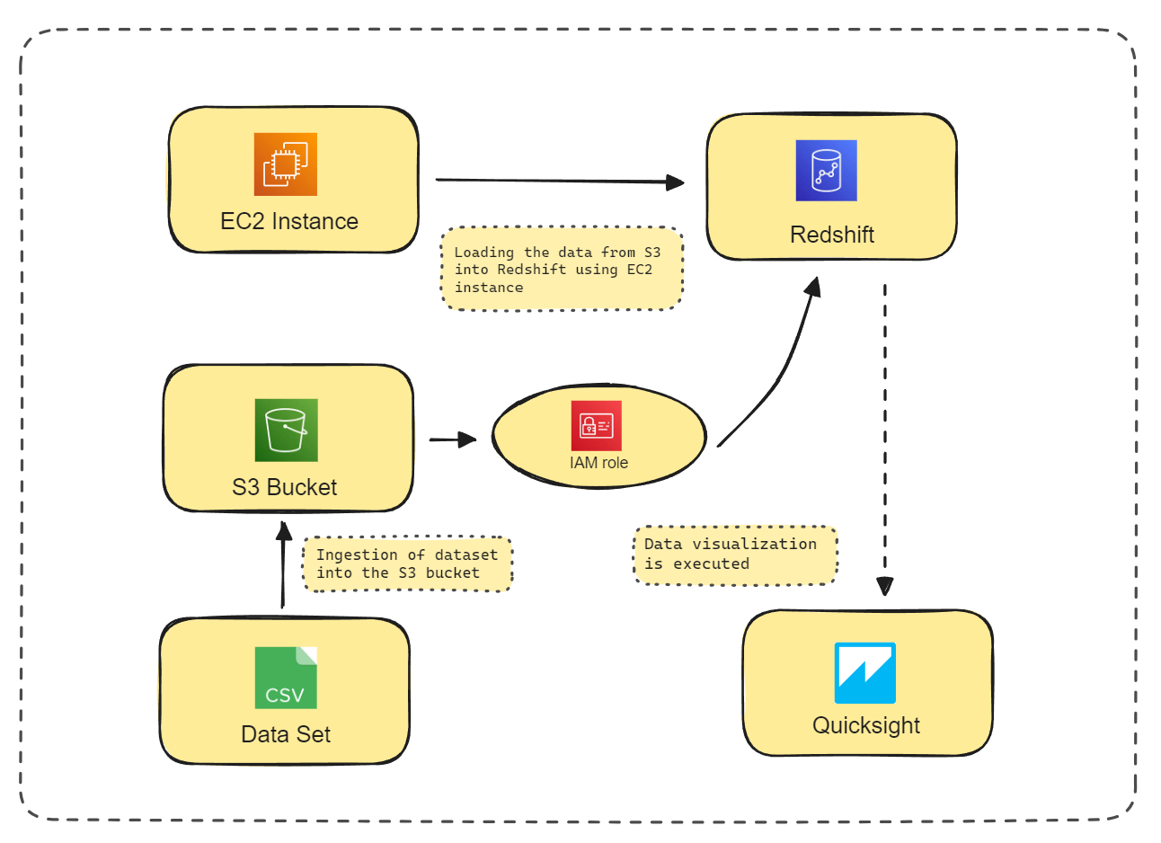

|  |  |  |  |  |  |
| --- | --- | --- | --- | --- | --- |
| 1  Fetching data from kaggle. And Loading the data to S3 bucket. | 2  Creating IAM role for S3 Access from Redshift | 3  Deploying a Redshift Cluster | 4  Deploy EC2 instance ,connect to Redshift, Load the data from S3 to Redshift . | 5  performing data analysis using Redshift Query Editor | 6  Loading the data to Quick sight and identifying trends and patterns through visualization. |

**Implementation of Project**

**Step 1:** Open AWS console

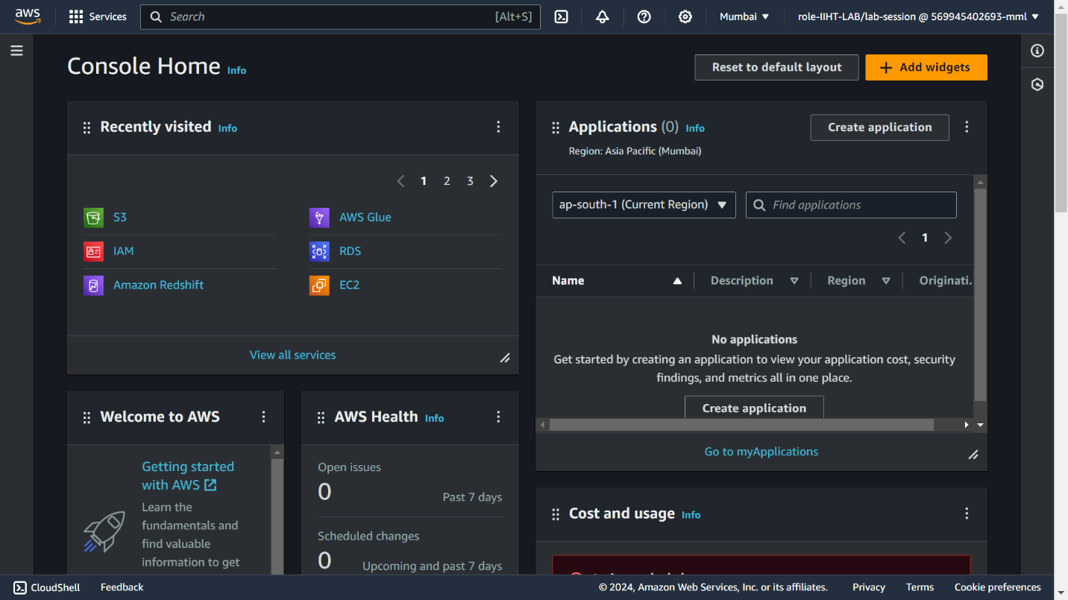

**Step 2:** Create VPC



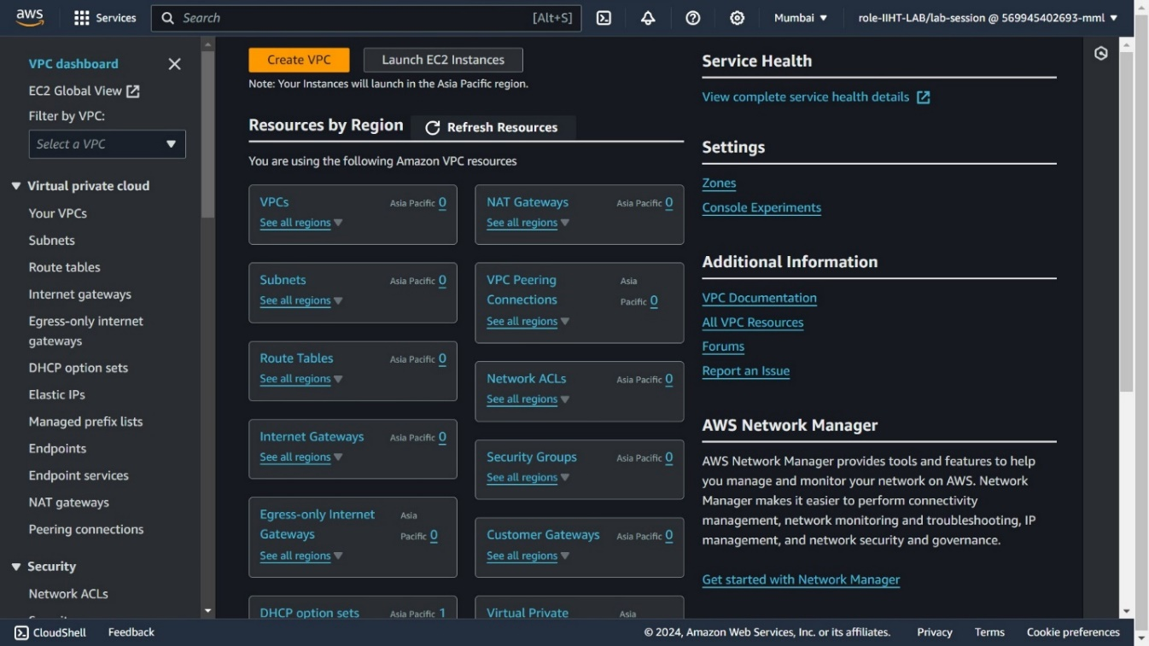

Open VPC and create default VPC and add subnets

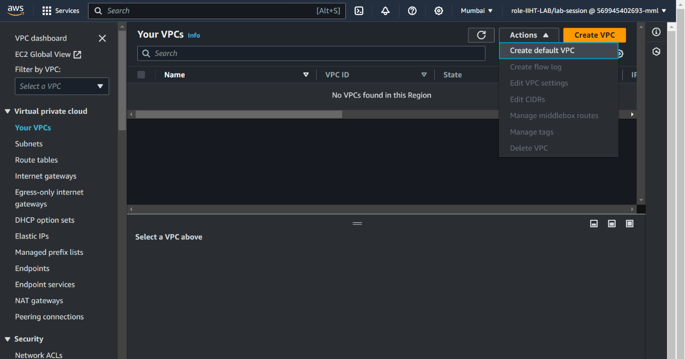

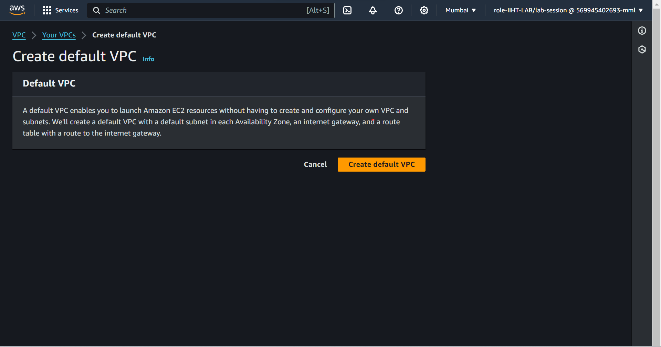

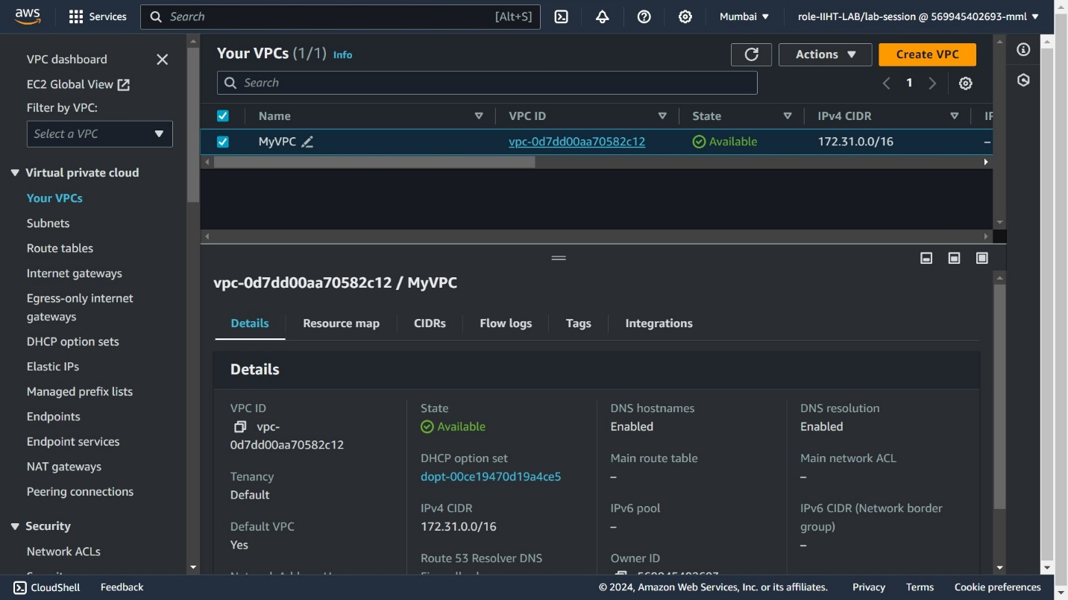

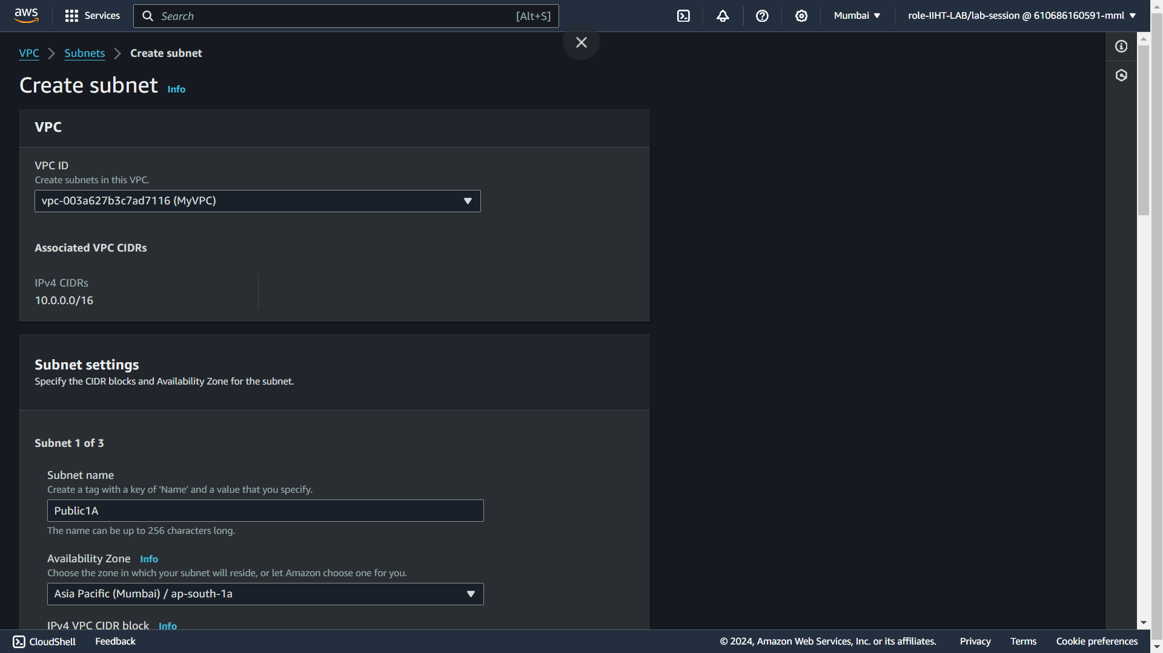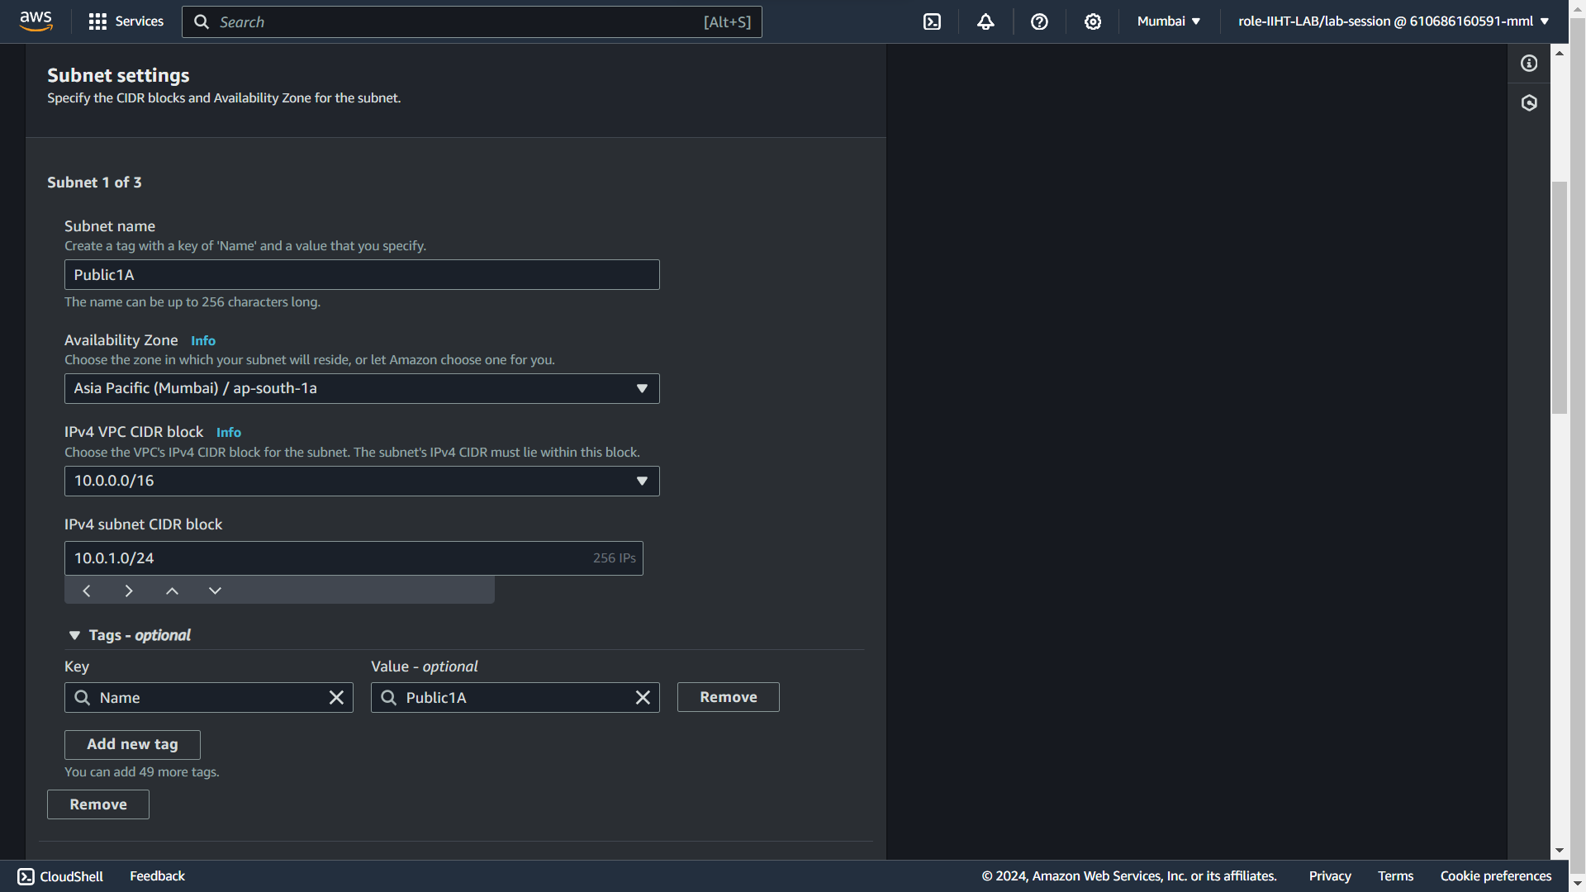

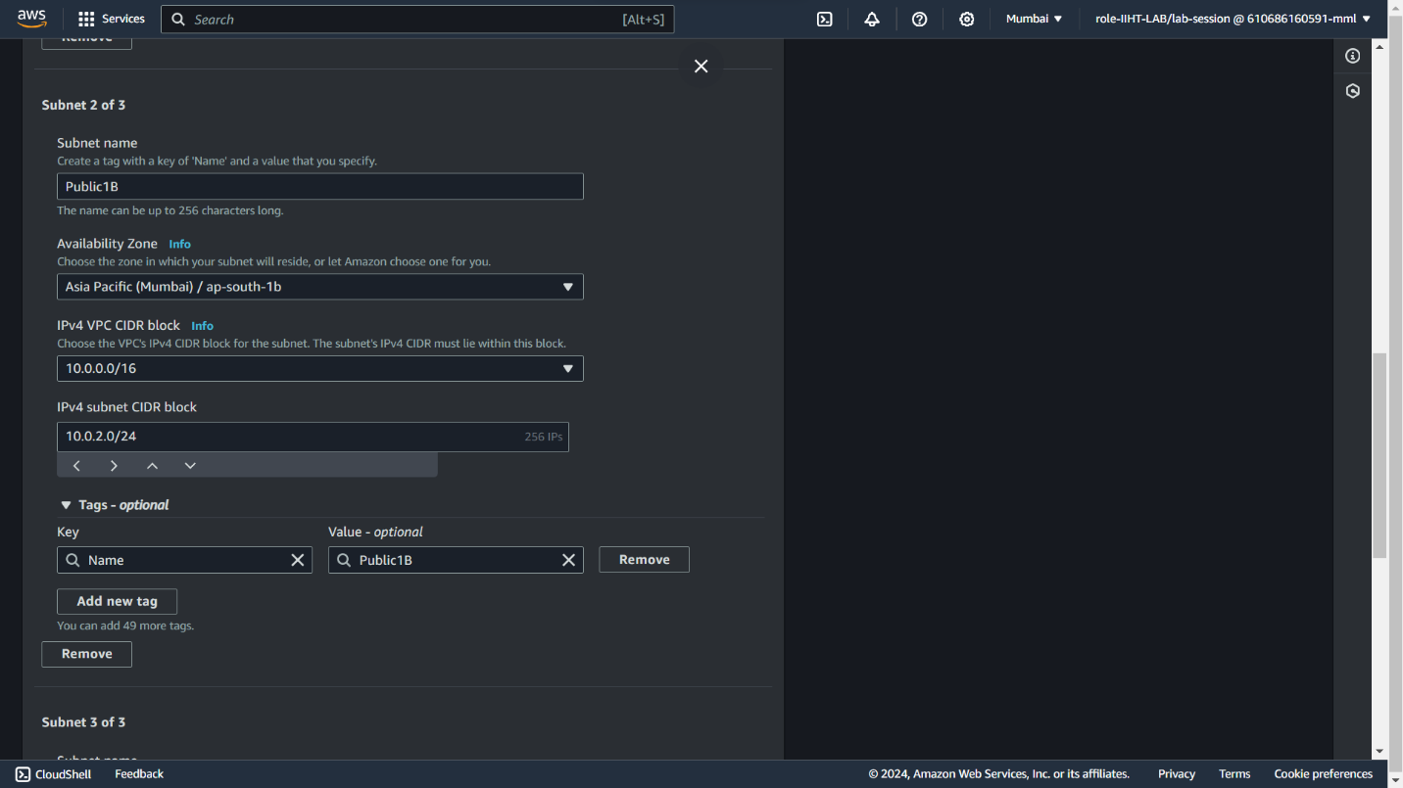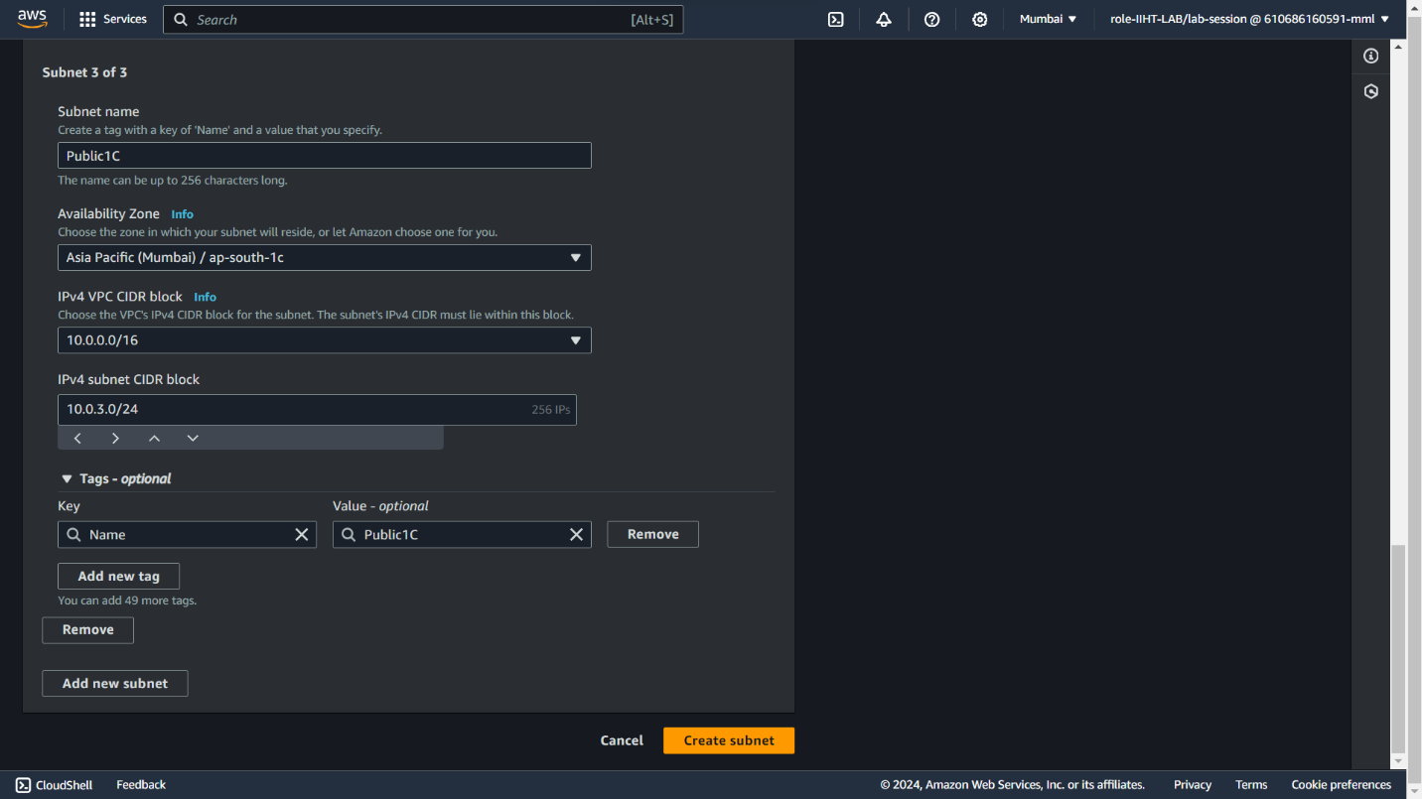

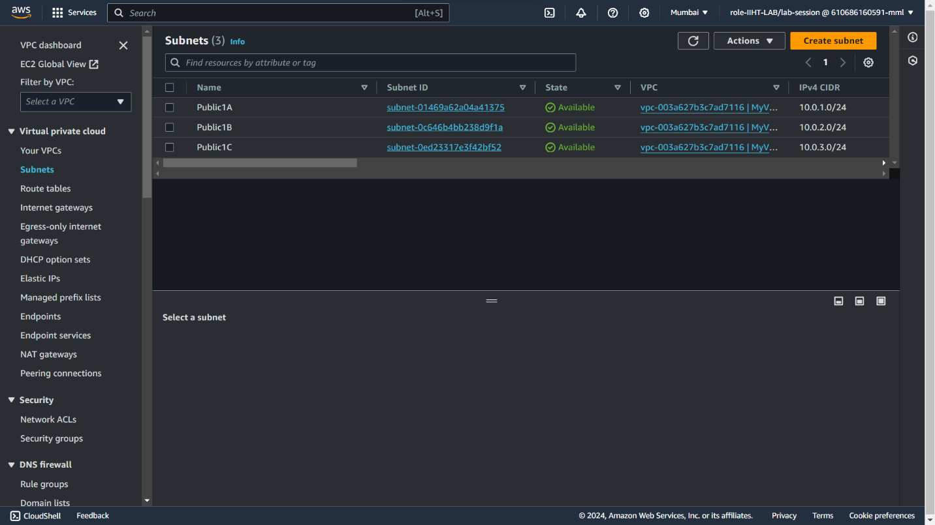

**Step3:** Creating Security Groups

There is a default security group we need to change the inbound rules to give access to redshift from S3

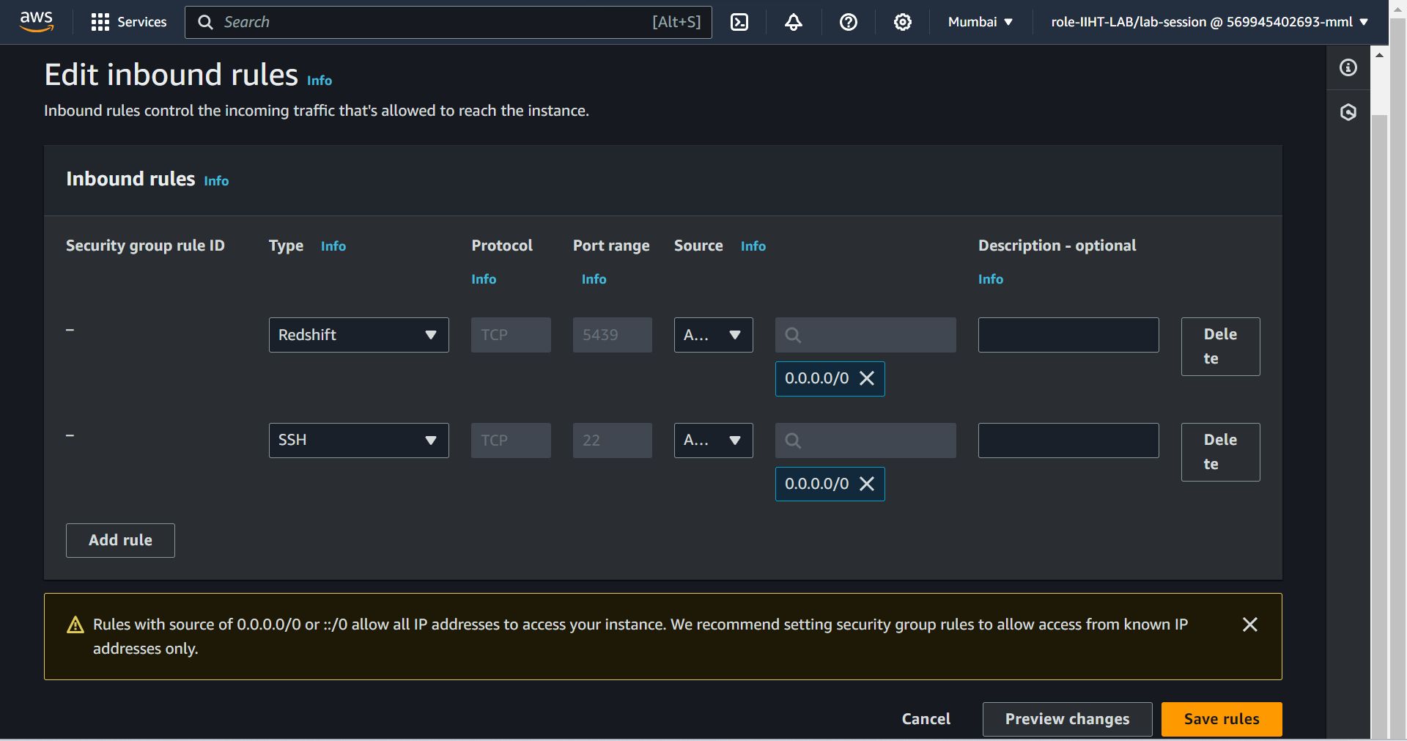

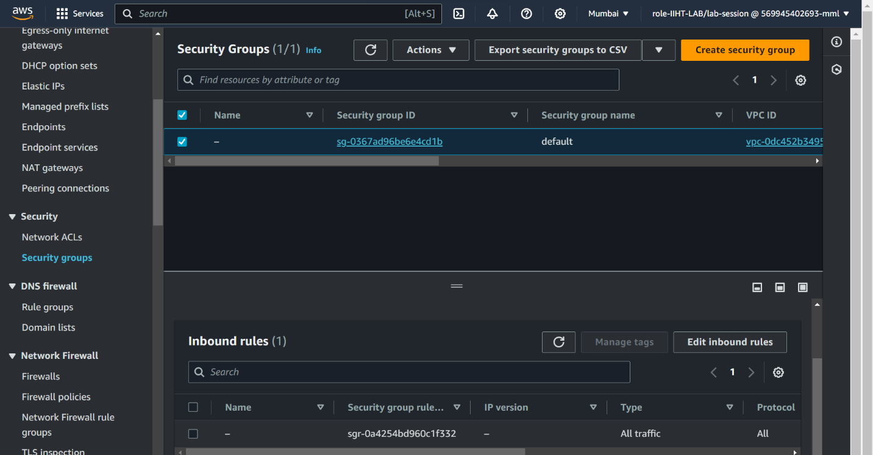



**Step 4 :** Open IAM Dashboard to create role for Redshift to access the S3

It is used to securely access the AWS services and resources. It helps to enhance the security by ensuring that only authorized individuals or system can interact with our AWS.

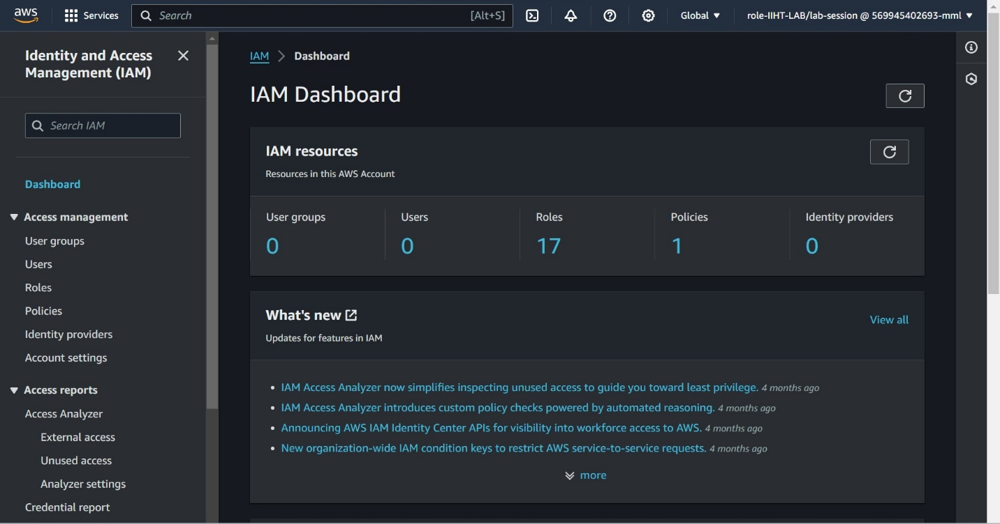

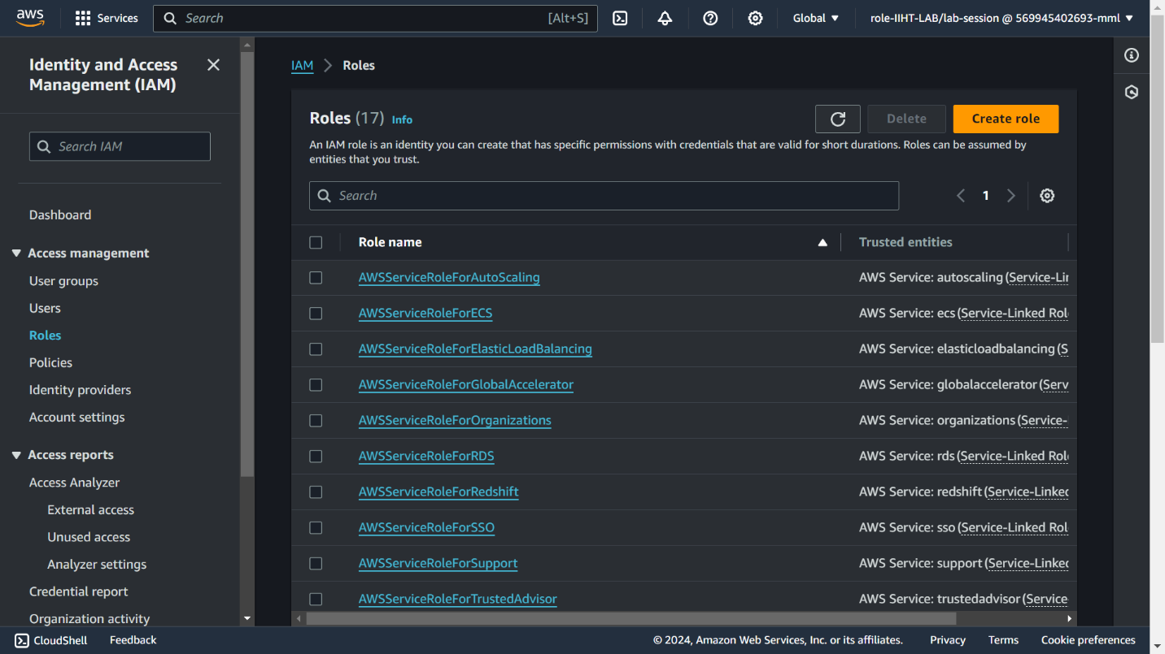

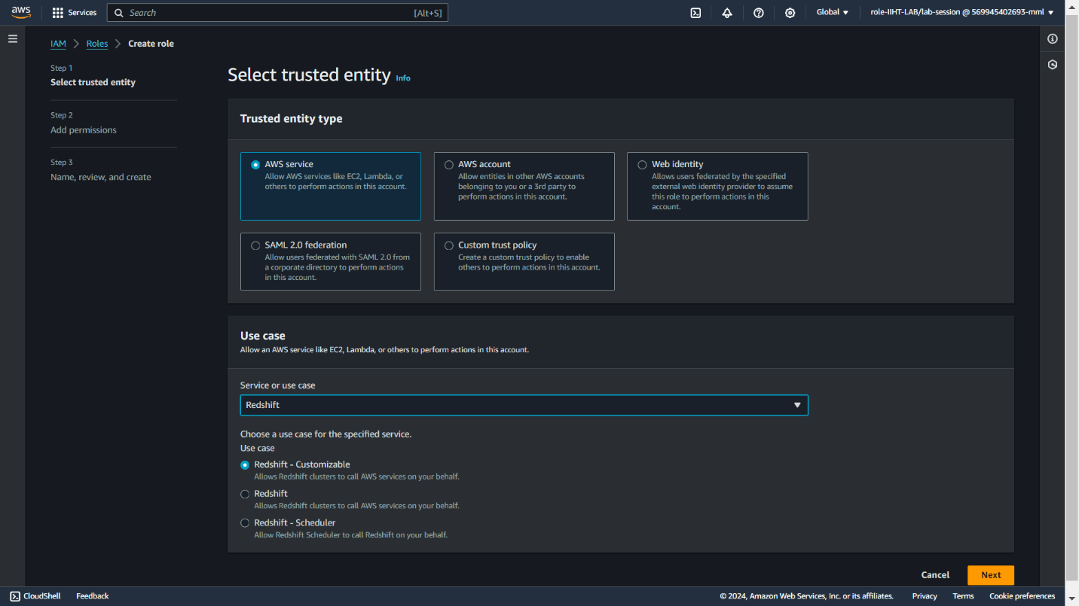

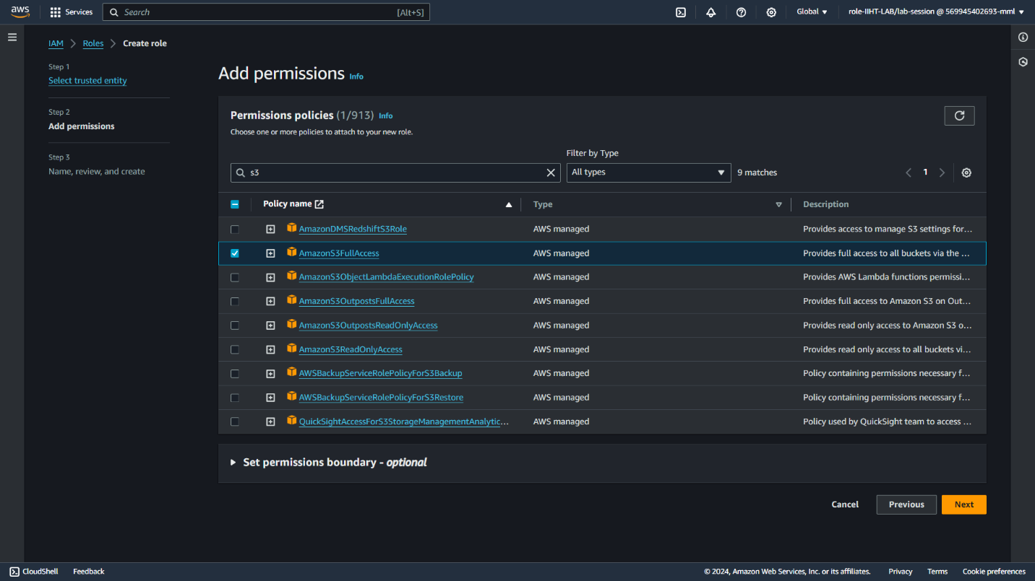

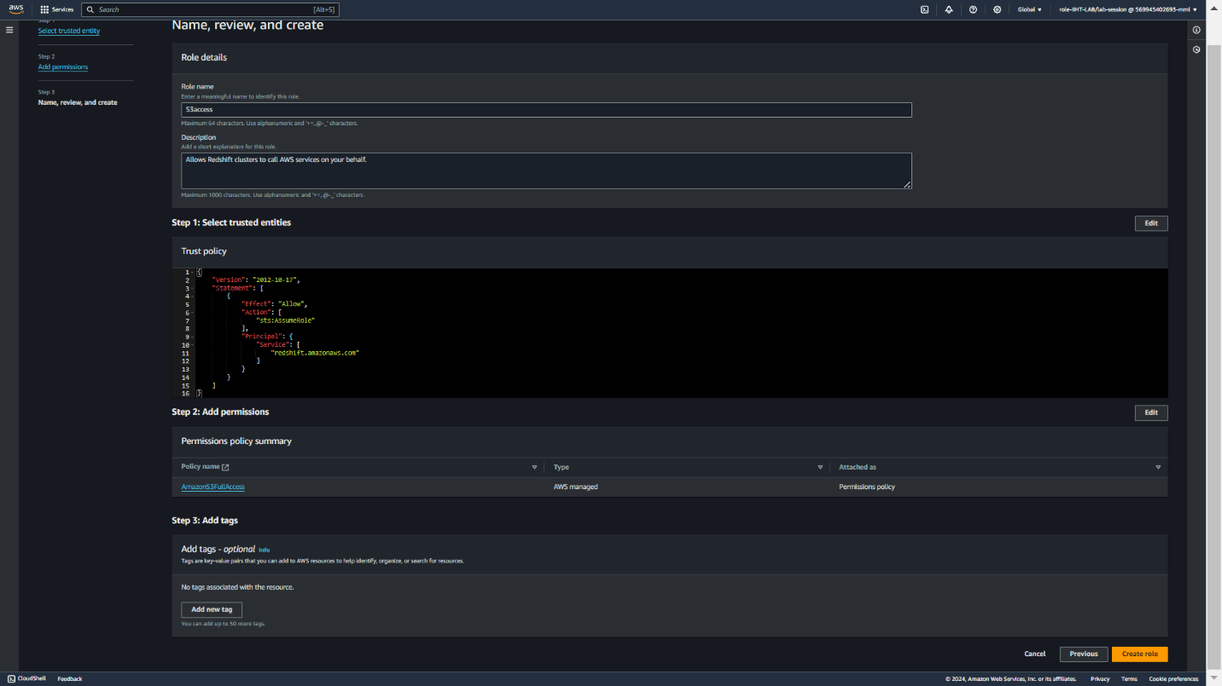



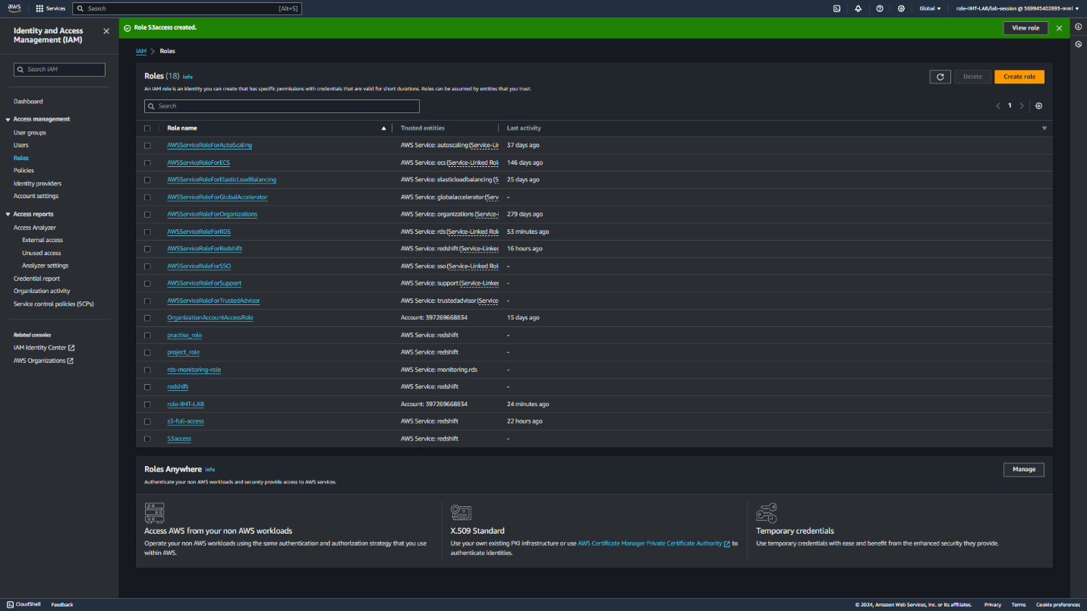



**Step 5:** Amazon S3 Bucket creation

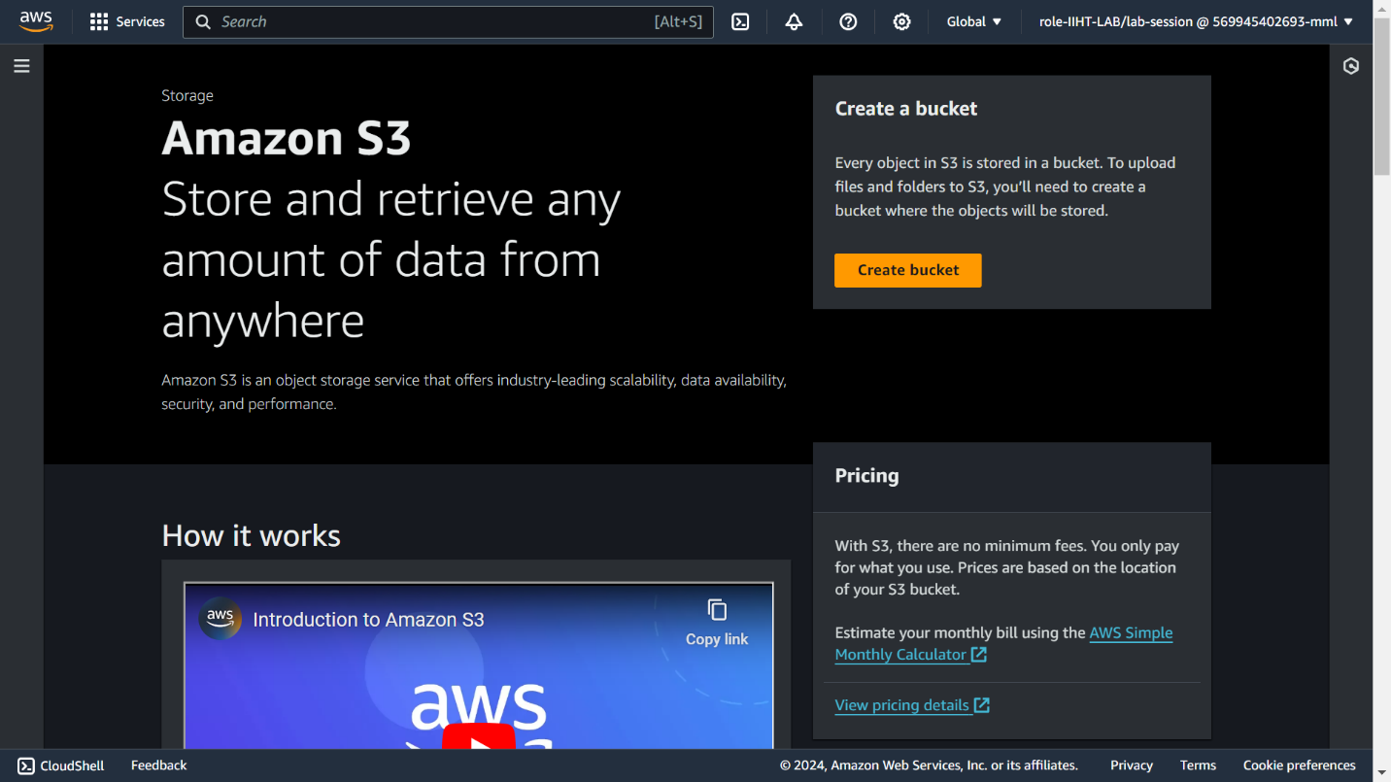

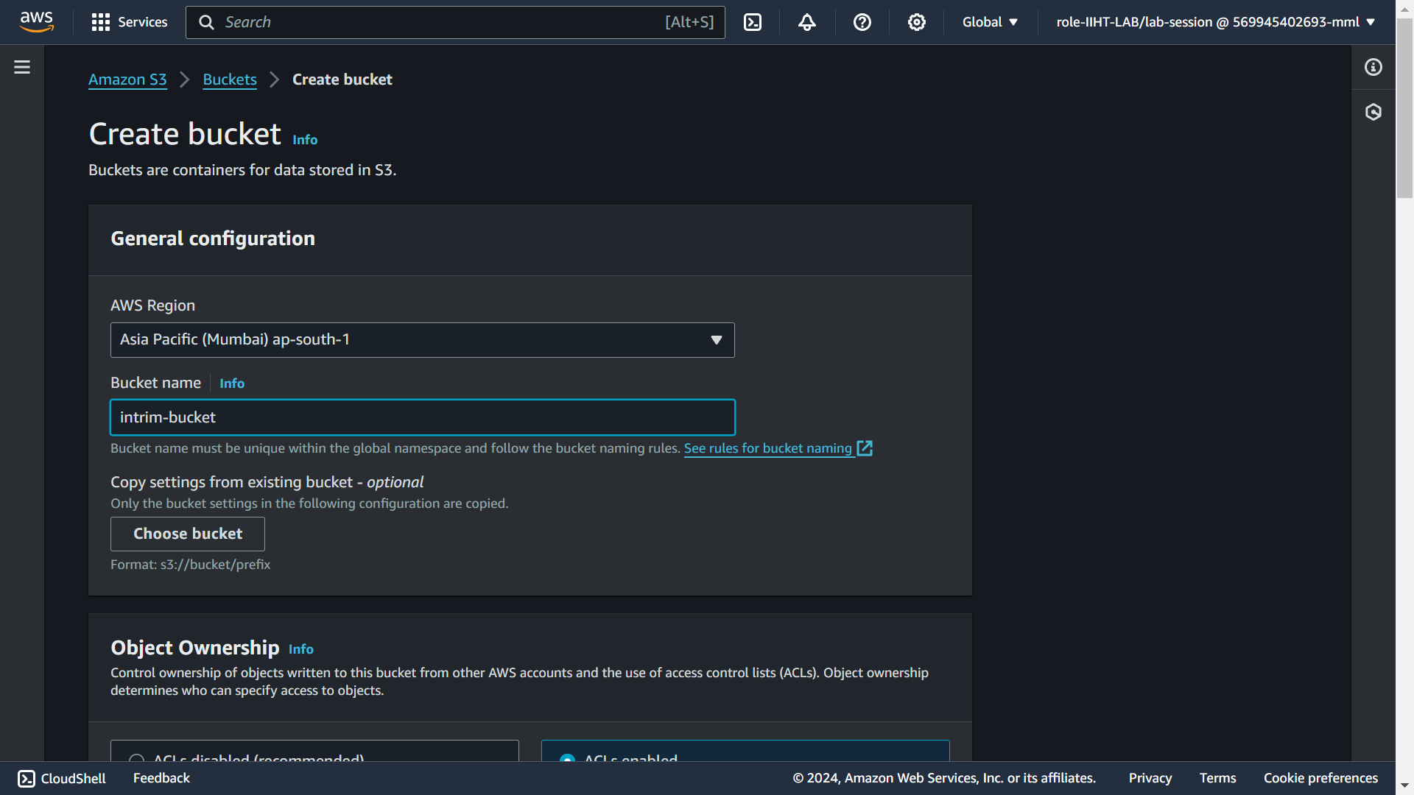

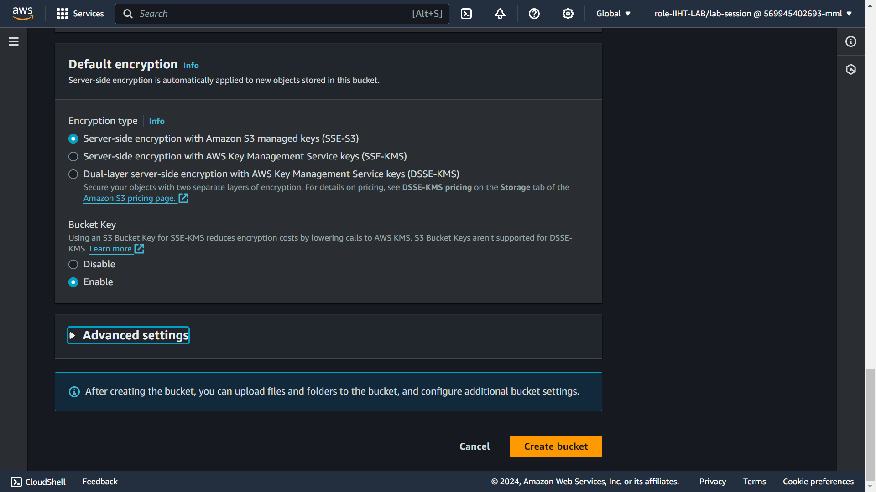

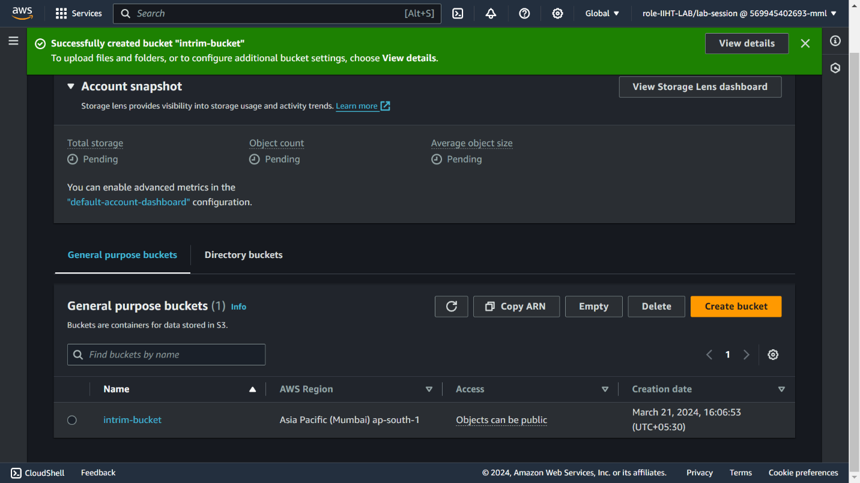



**Step6:** Uploading .csv file into S3 bucket

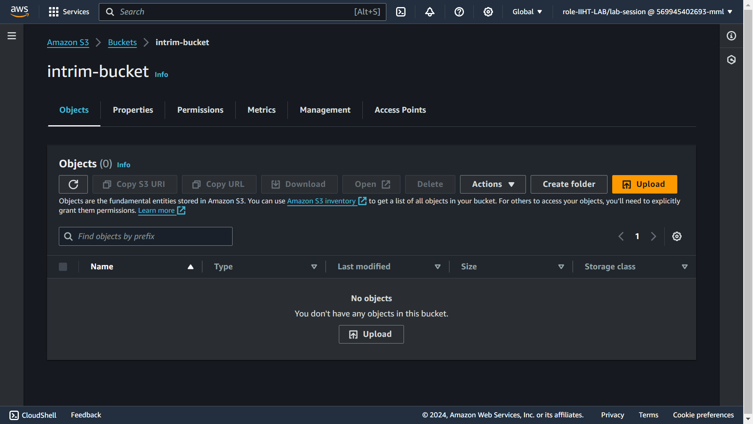

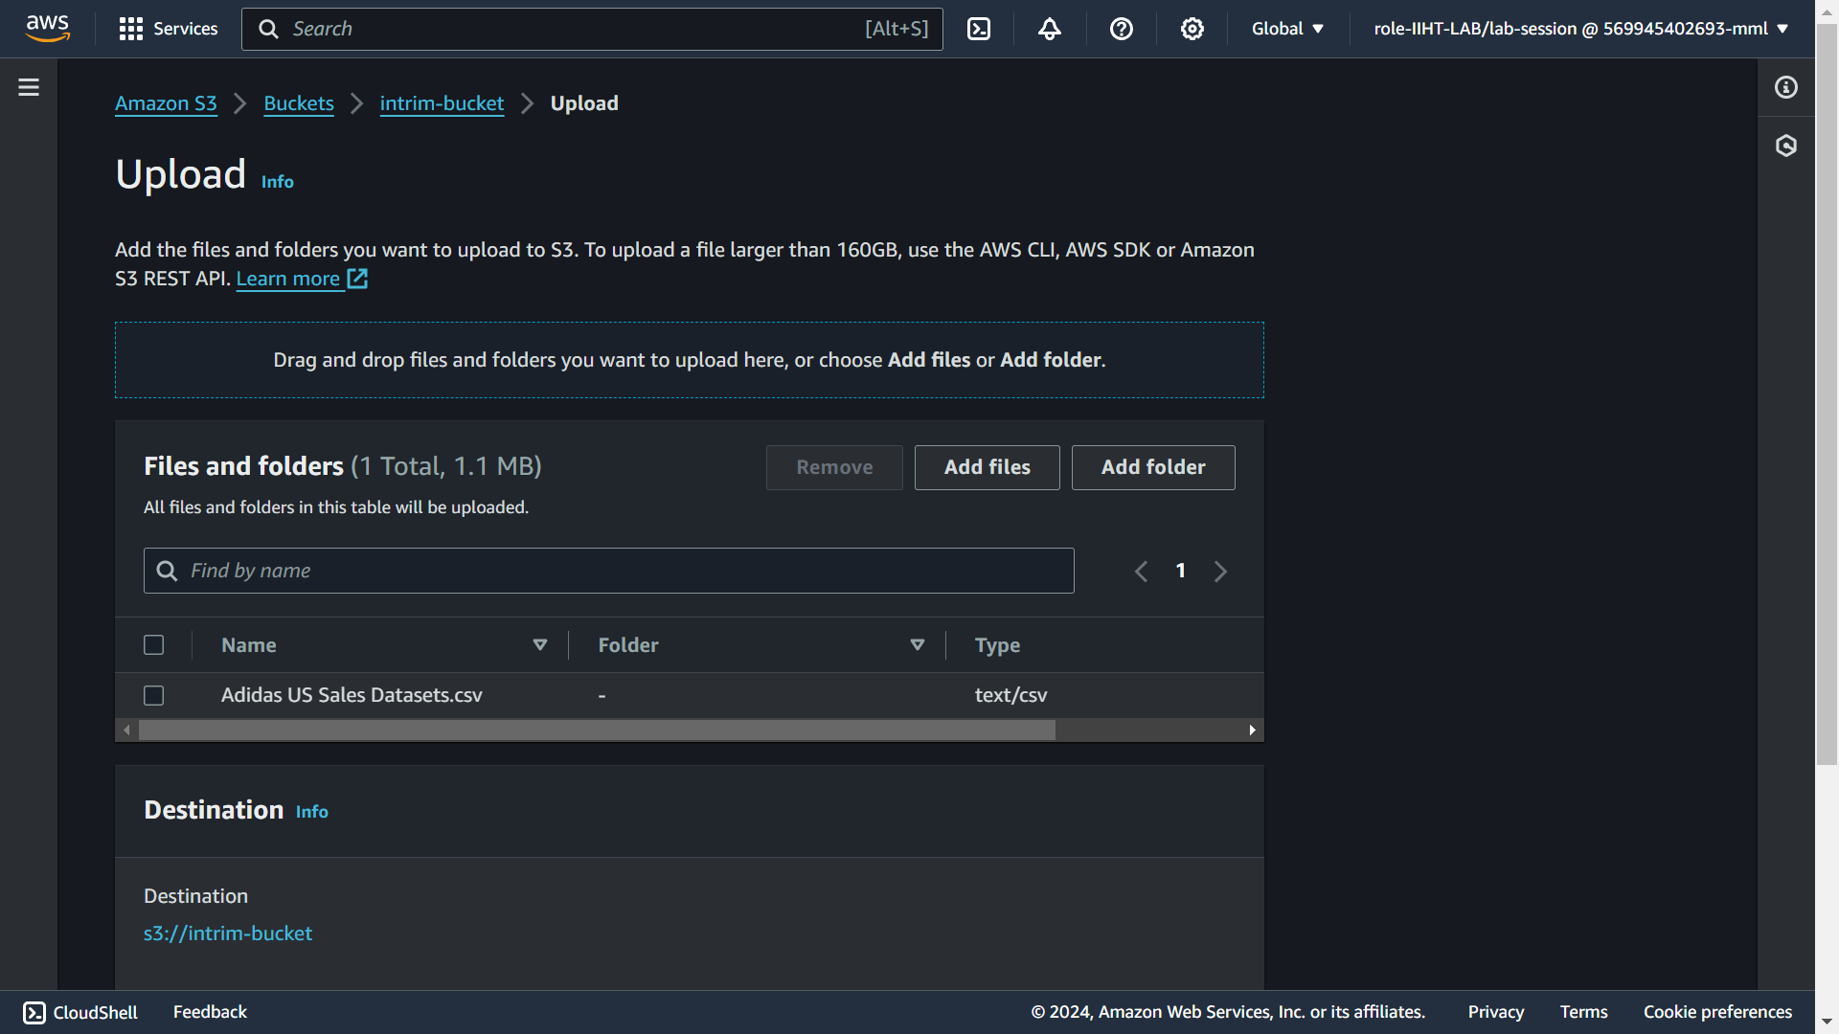

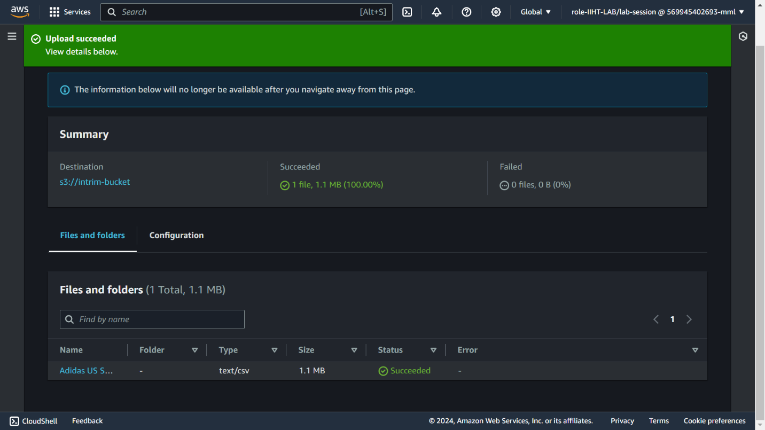



**Step 7:** Creating Cluster

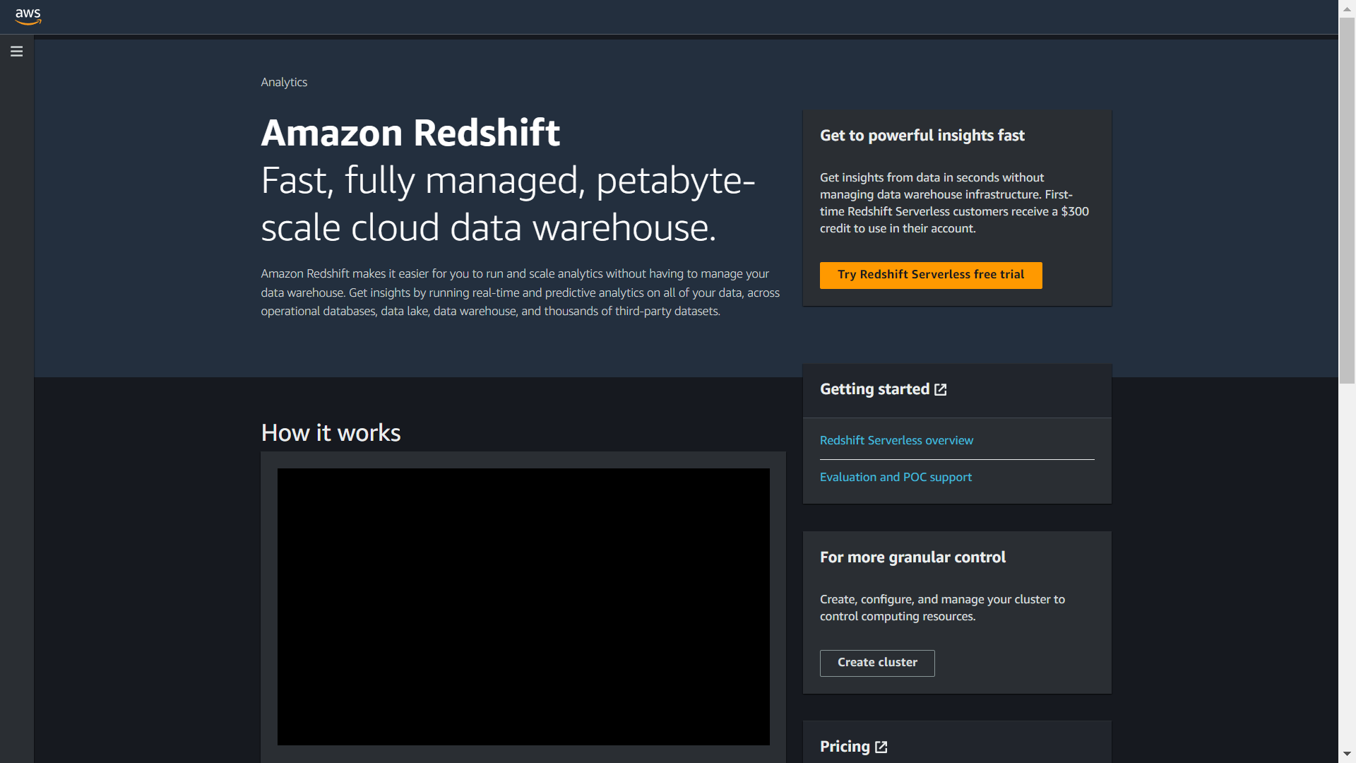

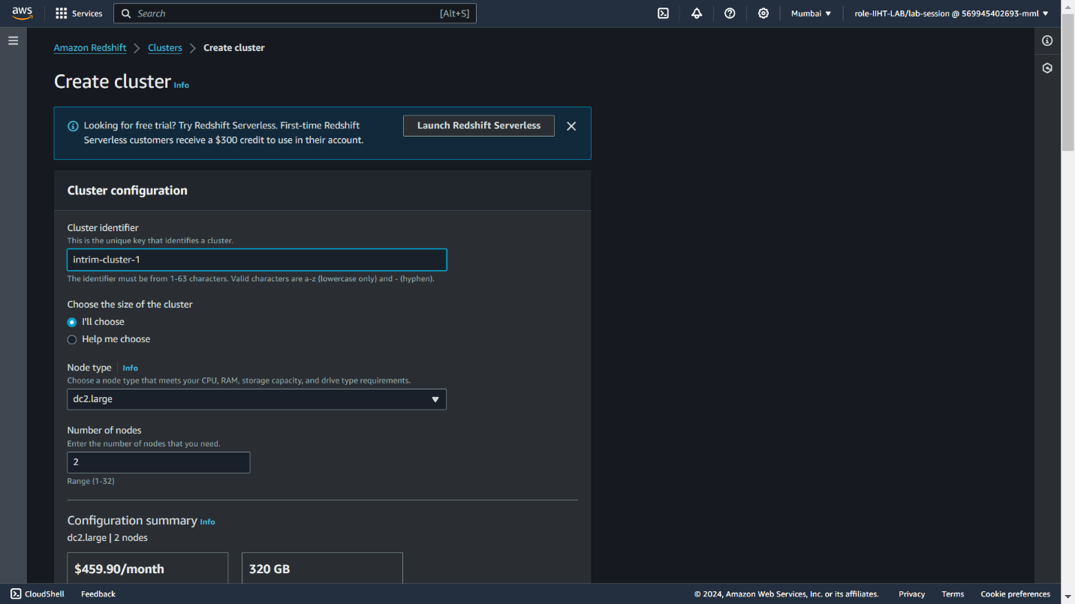

**Step 8:** Creating Cluster Subnet Group

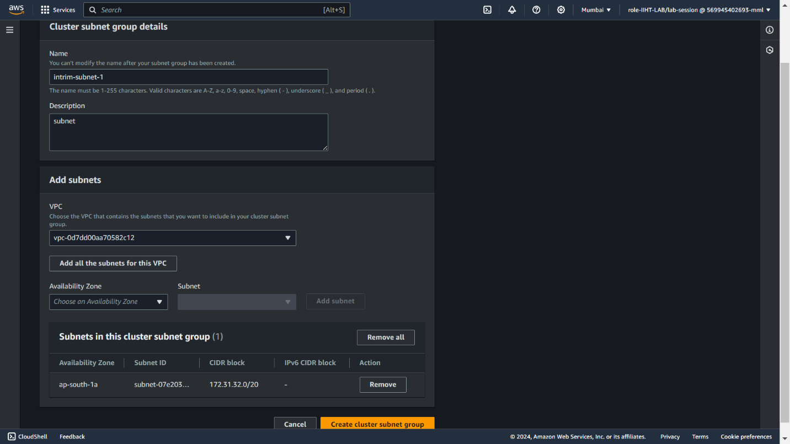

zzzzzzzzzzzz

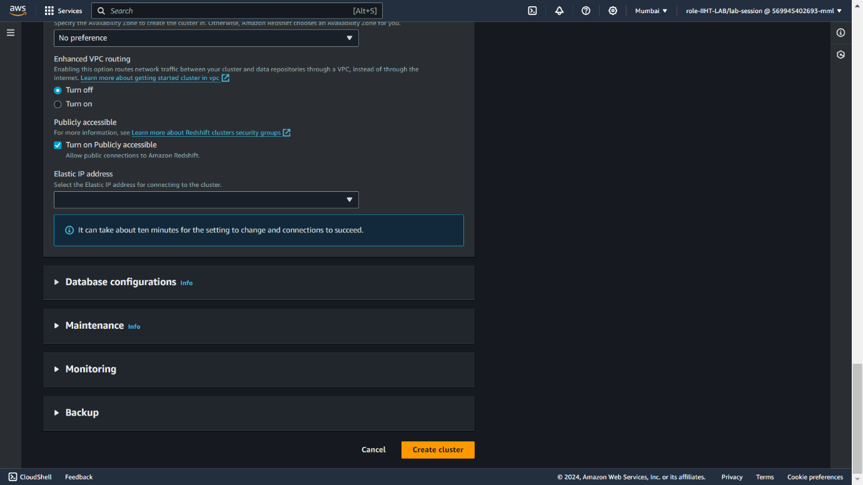

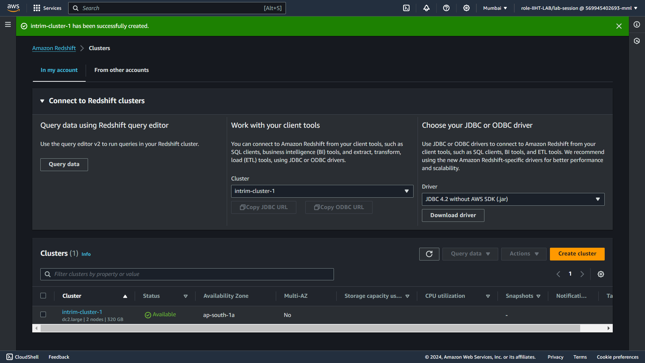



**Step 9 :** Creating an EC2 instance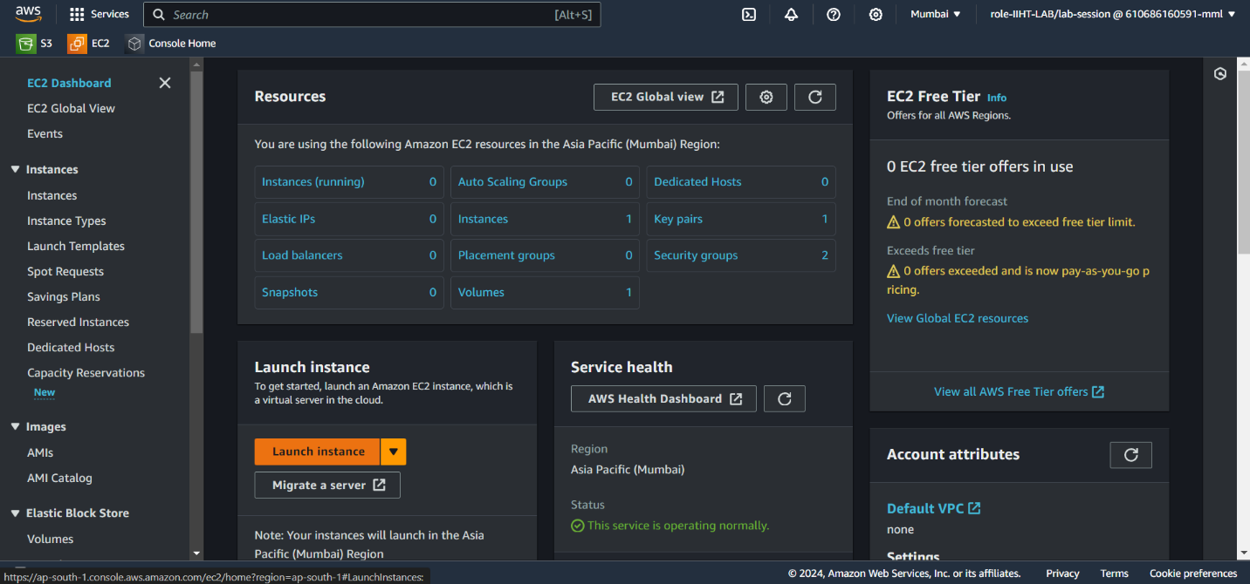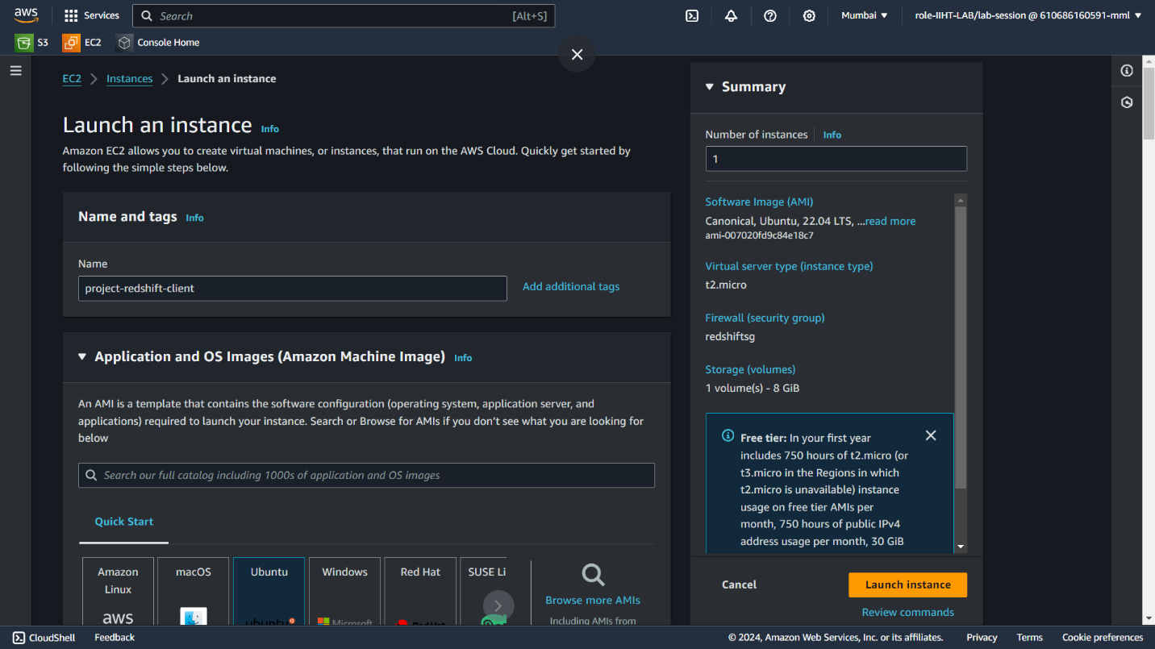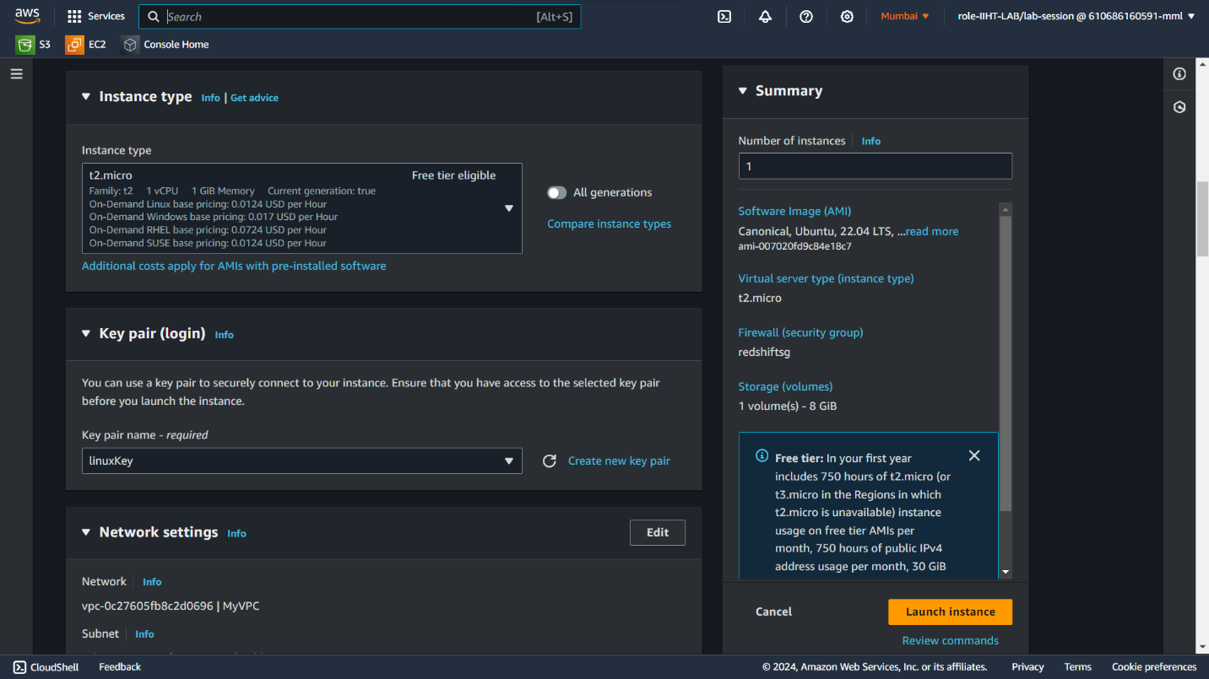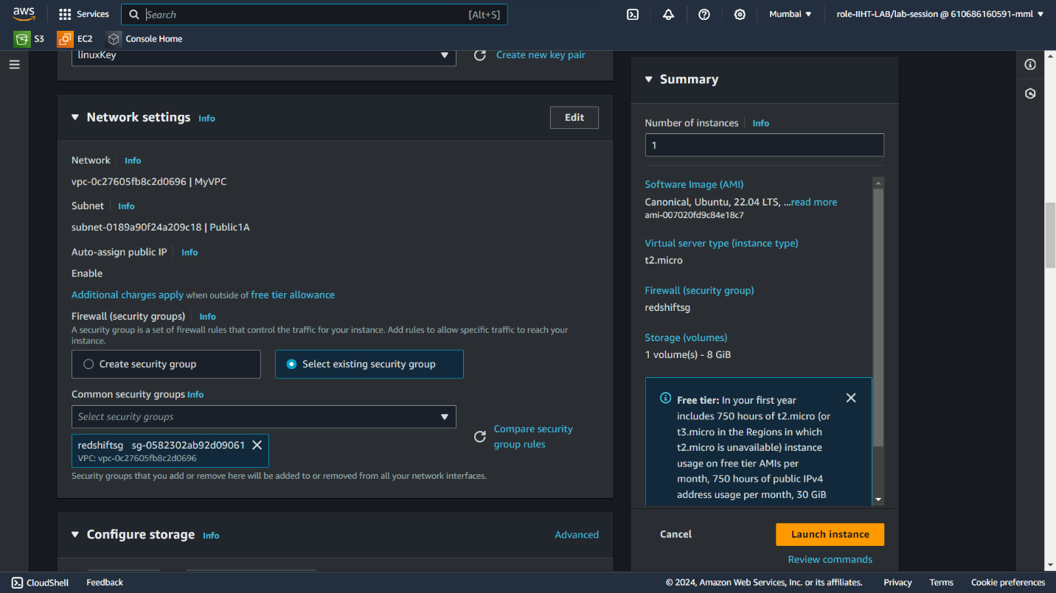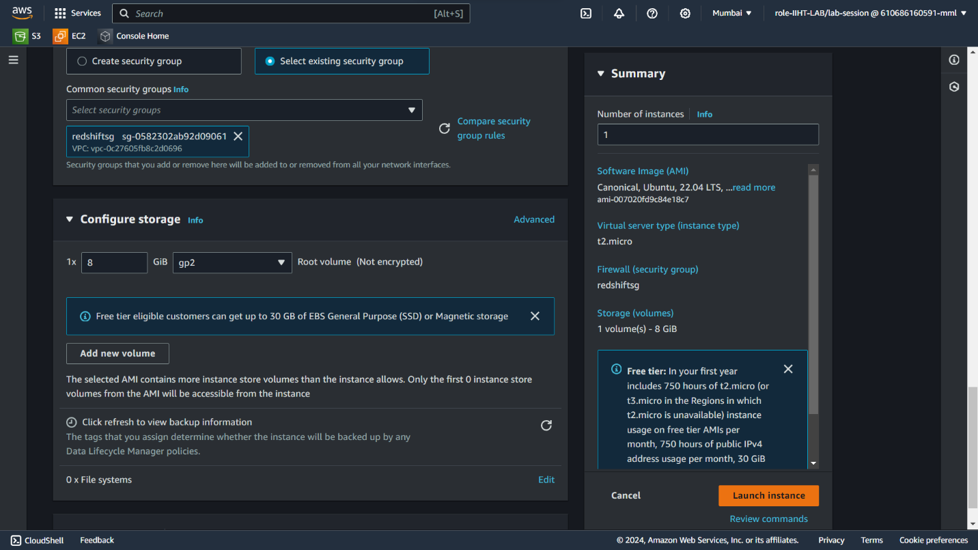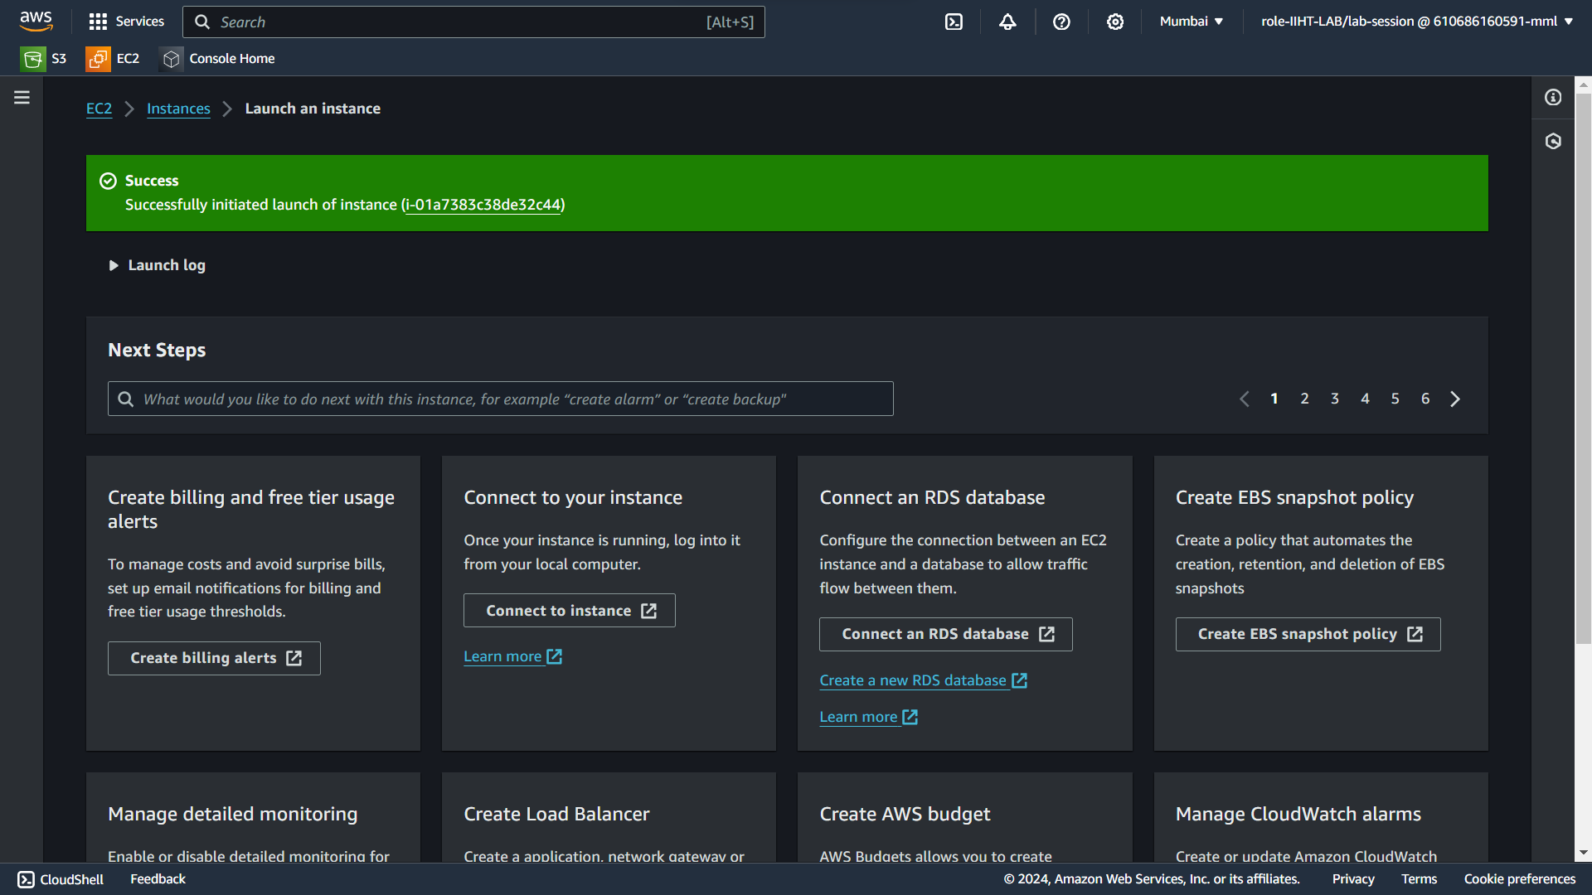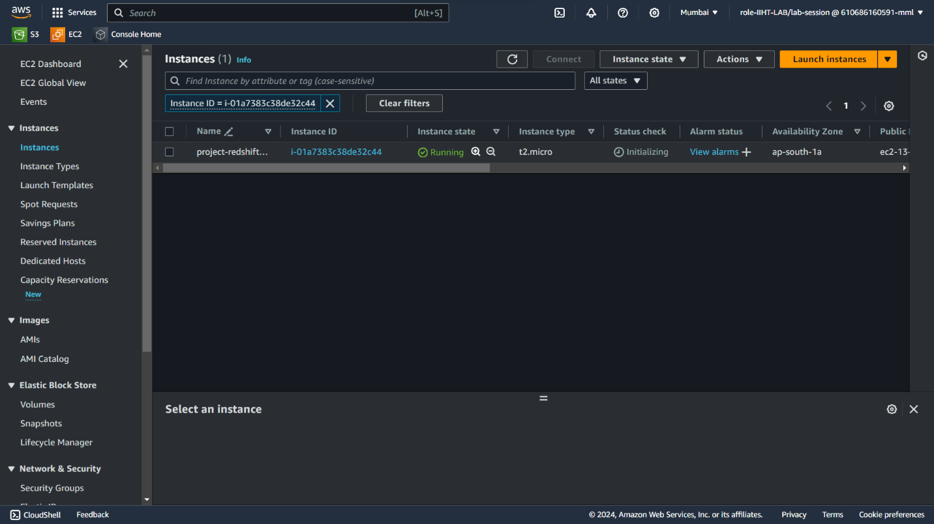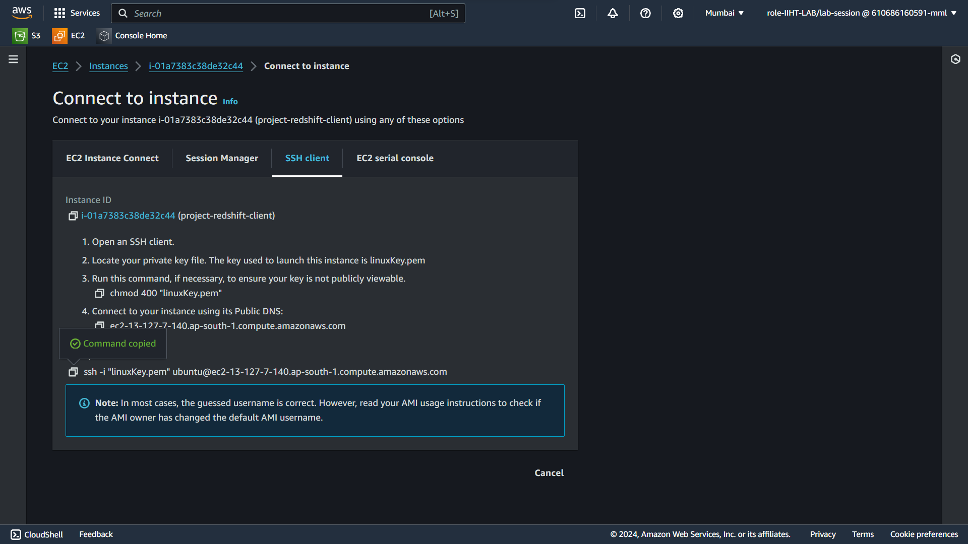



**Step 10 :** Open terminal and run the commands to create a table in Ec2 instance.

These are the commands to run the table in Ec2 instance.

* “sudo apt-get update
* sudo apt-get install -y postgresql-client && psql --version
* psql -h redshift-cluster-1.cjlluv3z3ar1.ap-south-1.redshift.amazonaws.com -p 5439 -U awsuser -d dev -W”

Syntax : pql –h <hostname> -p <port> -U <user> -d <database> -W

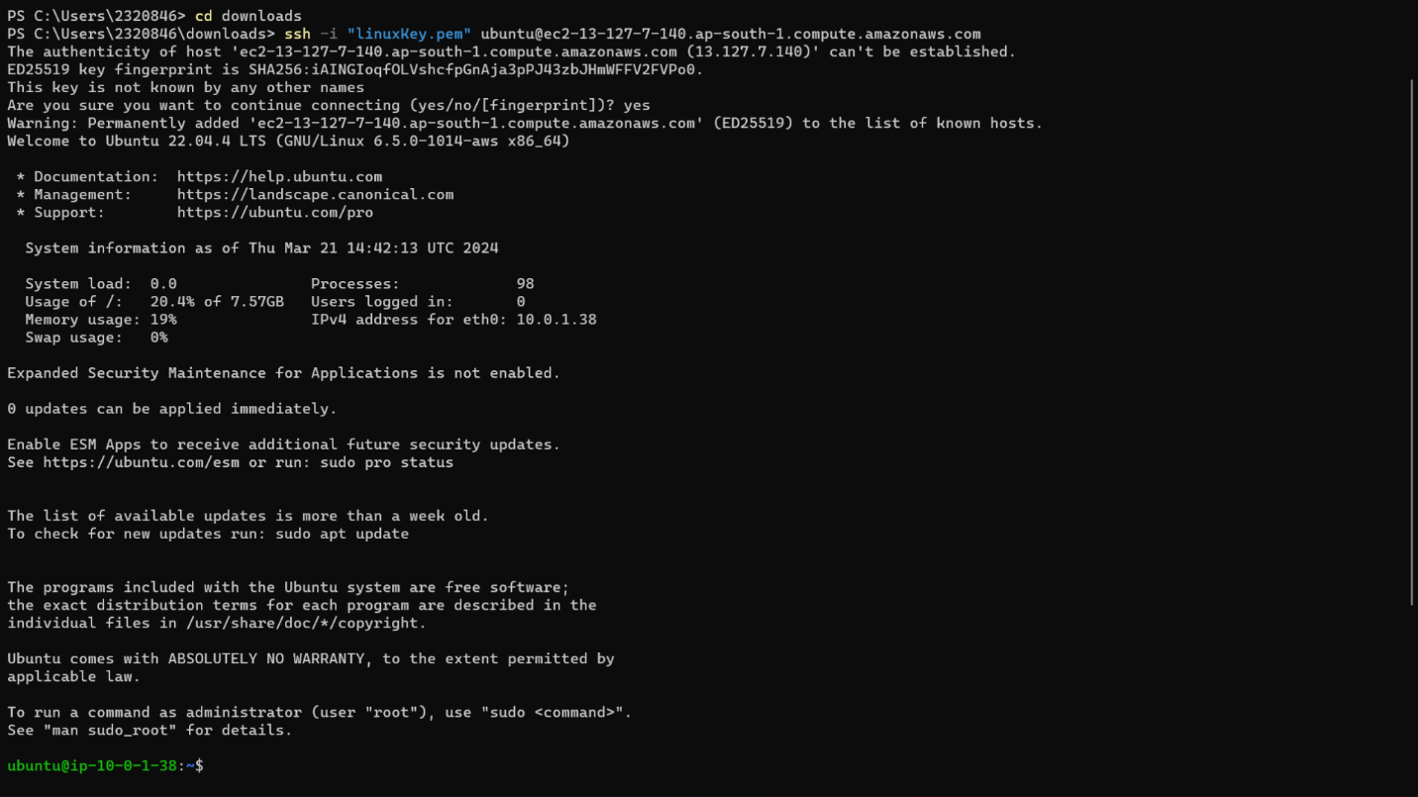

* Connecting to the Redshift cluster from ec2 through postgreSQL client



* create database for our use

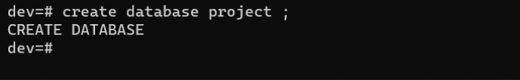

* Again we connect to Redshift and login to the created database
* Create a table

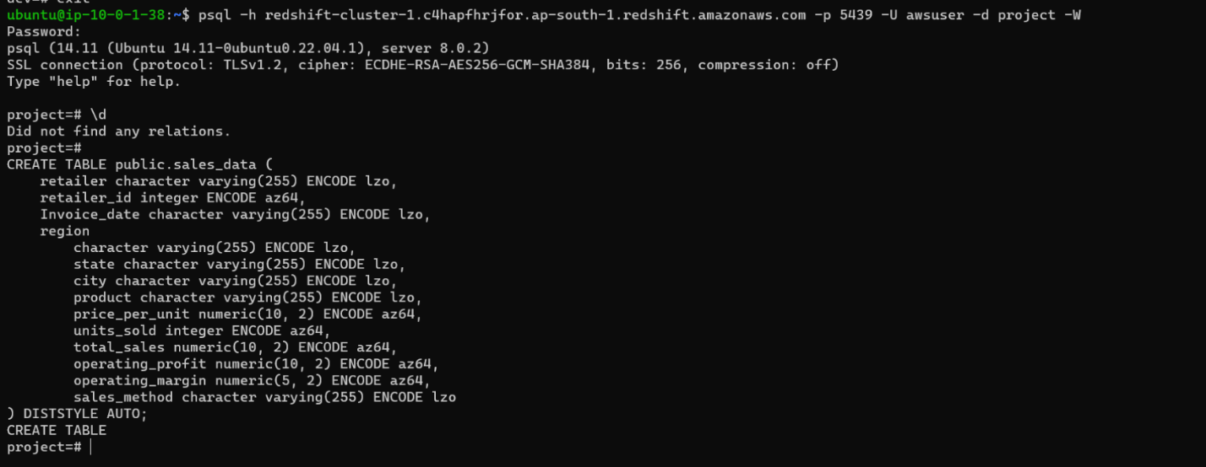

**Step 11:** Load the data from S3 to Redshift

To load the data we need S3 object URI

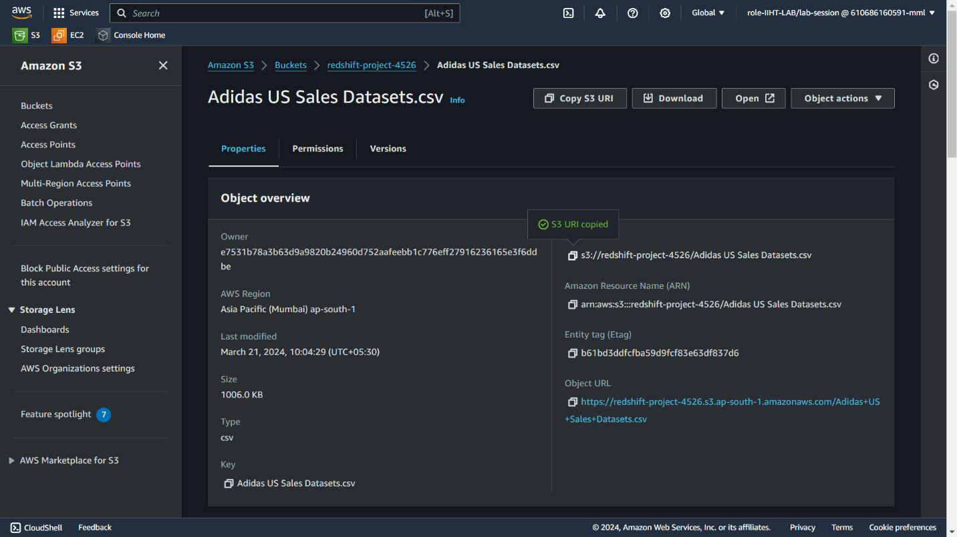

We need the IAM S3 Role ARN that we created earlier

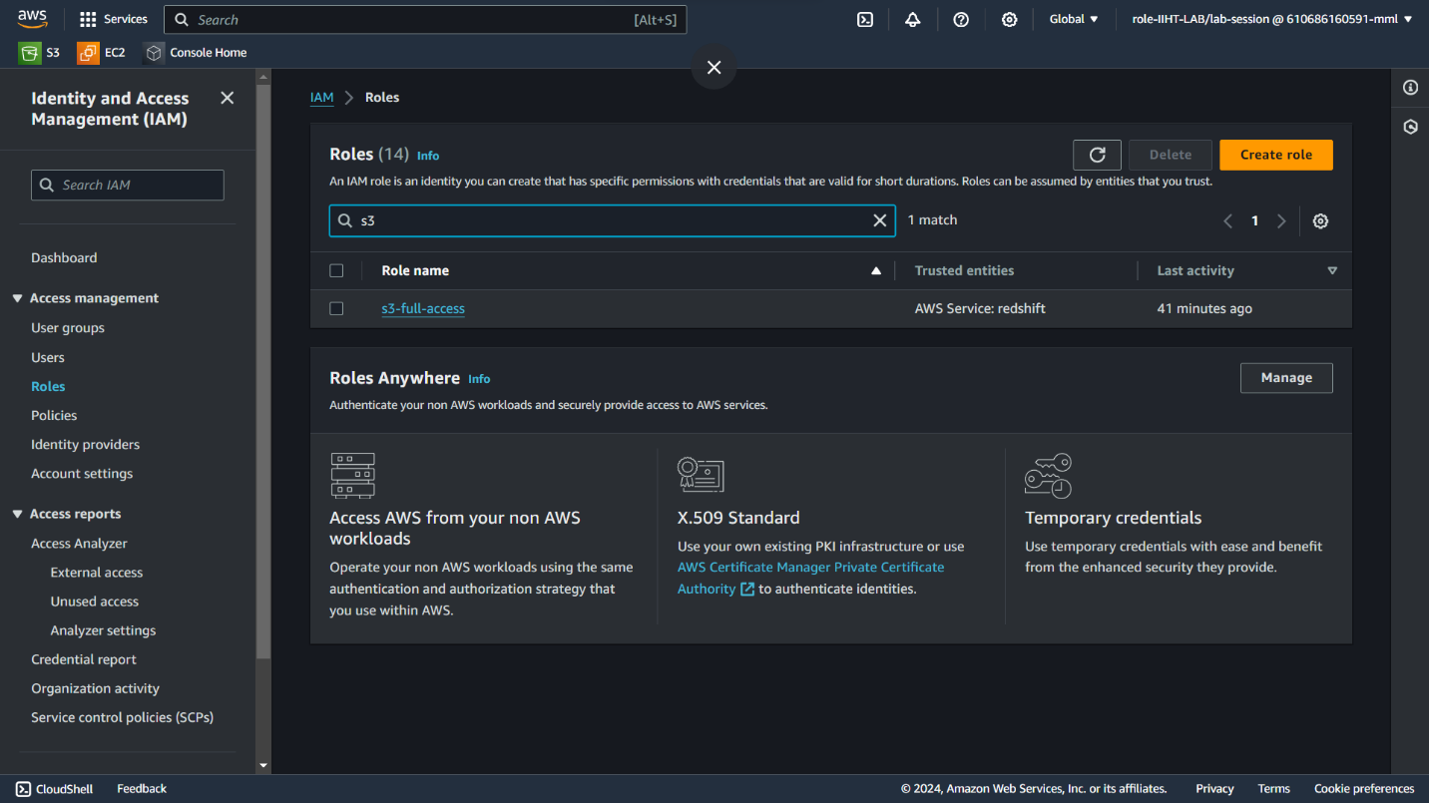

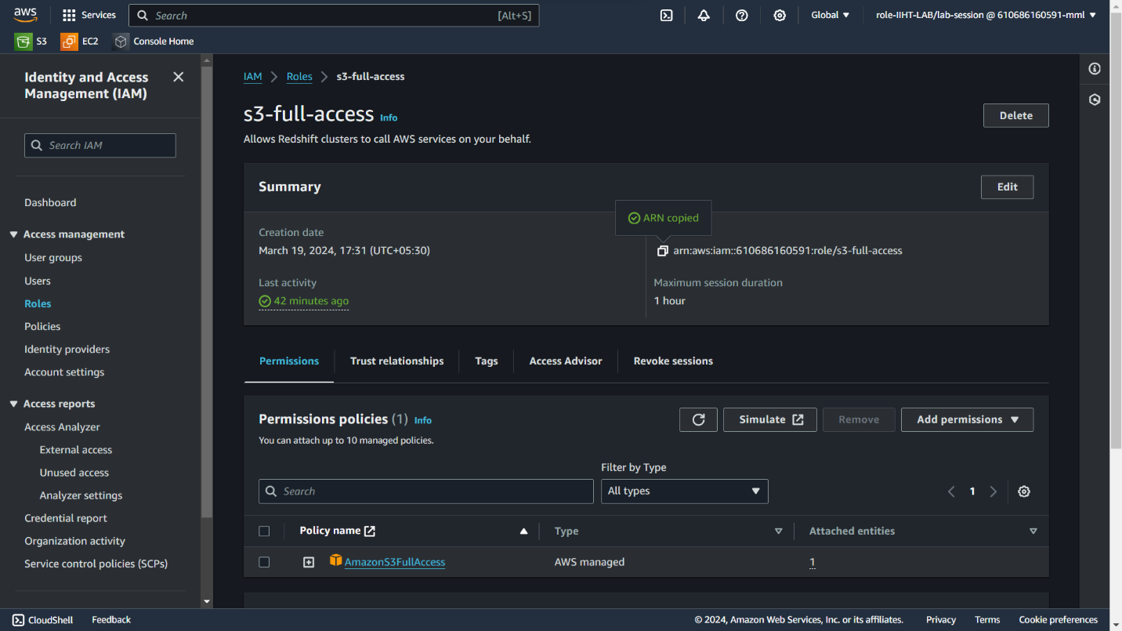

Then use the following command to load the data

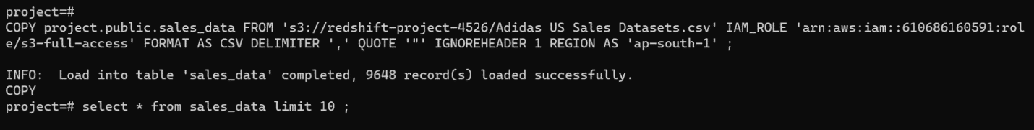

COPY <tablename> FROM <S3 bucket URI> IAM_ROLE <IAM role A> FORMAT AS CSV DELIMITER<file delimiter> REGION AS <cluster region>

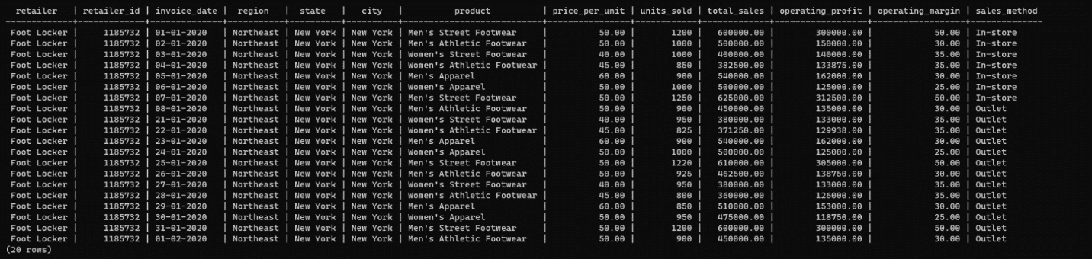

Database schema :

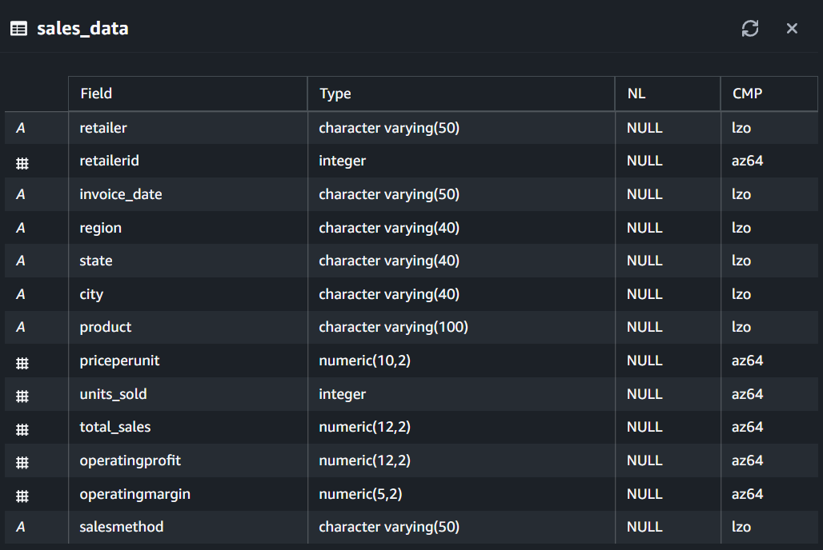

**Step 12: Data Cleaning**

Looking at the data we found some data mismatch , so we have to clean the data first before performing any analysis on the data .

* First we have to change the invoice_date colum from character variable to date format

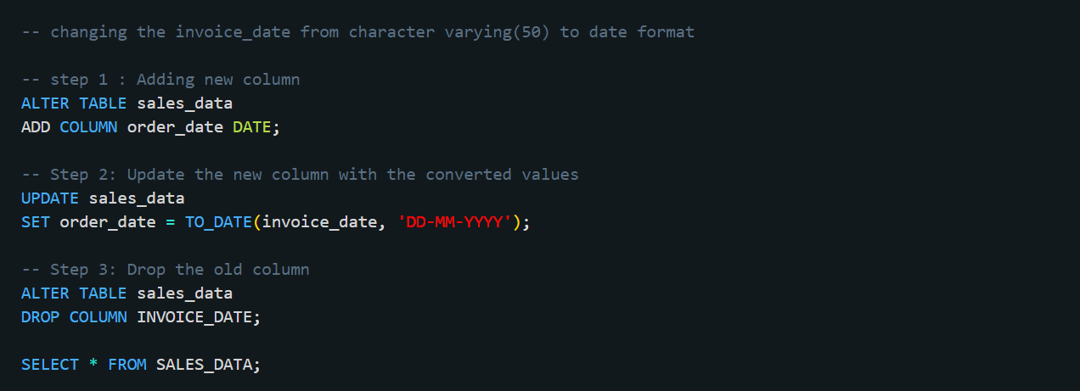

Now the schema looking like this

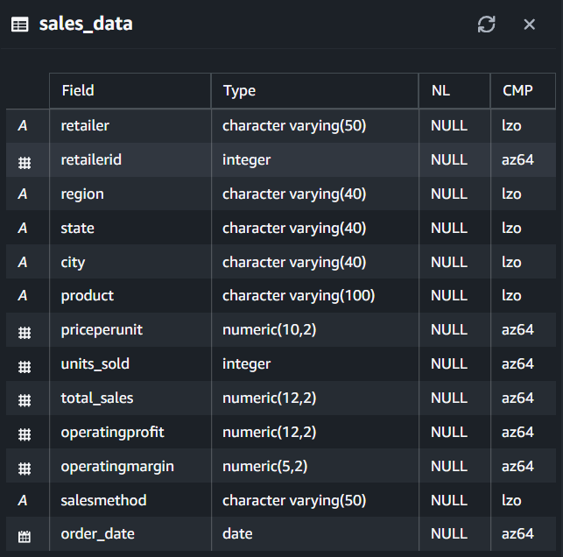

* We observed that in the dataset the some column’s data was mismatching , these columns are
  + Total_Sales column
  + Operating profit column



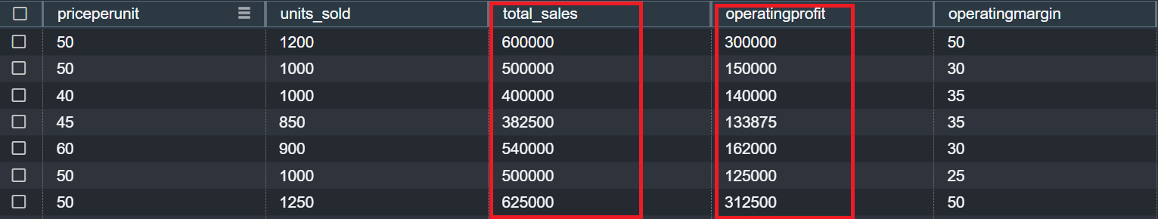

So we perform some more data cleaning for

Total_Sales :

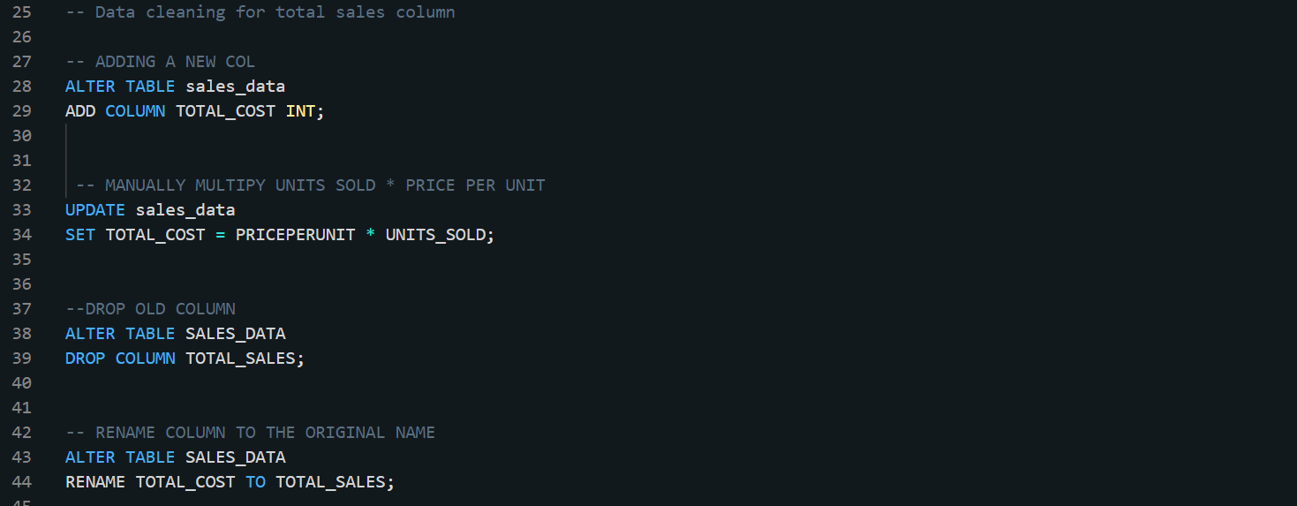

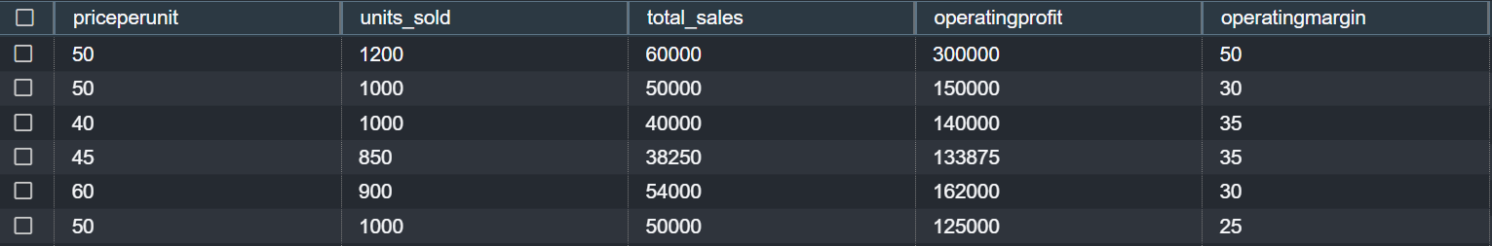

Operating profit :

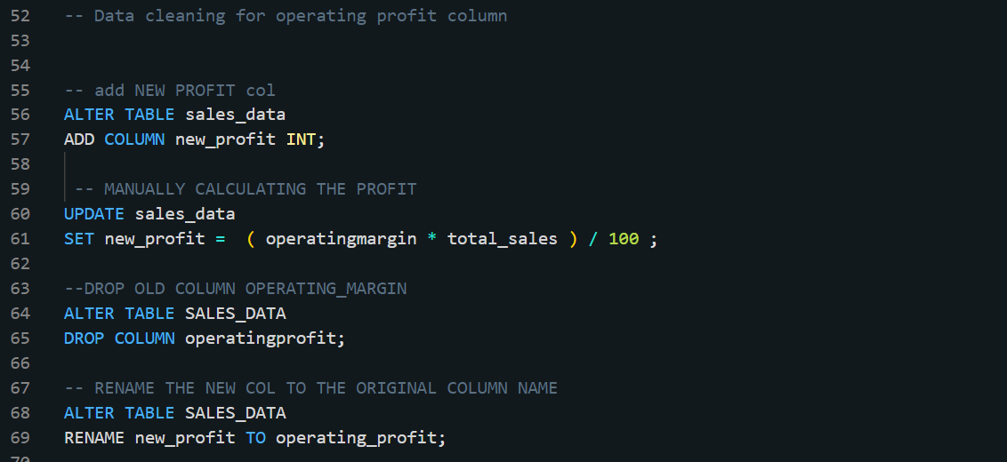

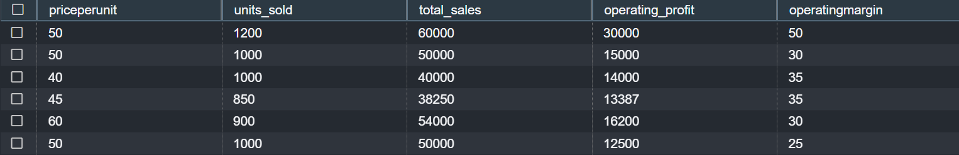

Now we will move to Redshift cluster to run the queries

Note: We can directly run queries from the instance but for better visuals we used Redshifts query editor v2

**Step 13: Running SQL queries to analyze the sales trends**

SQL queries to aggregate sales data by product, region, and time period.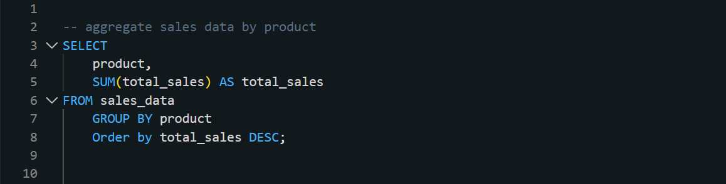

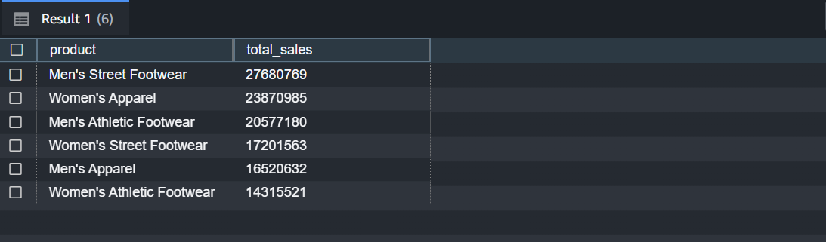

By Region

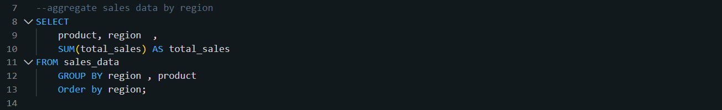

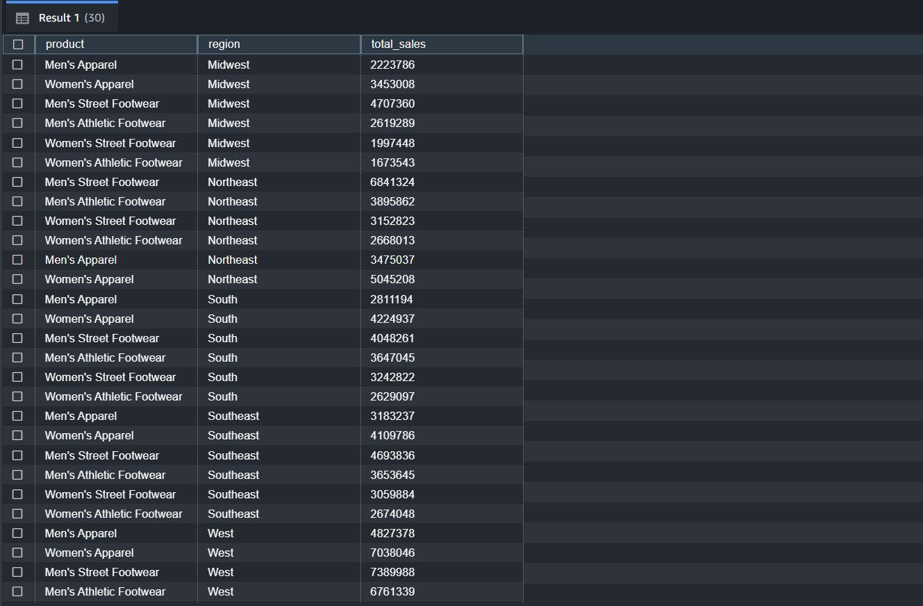

By Time period

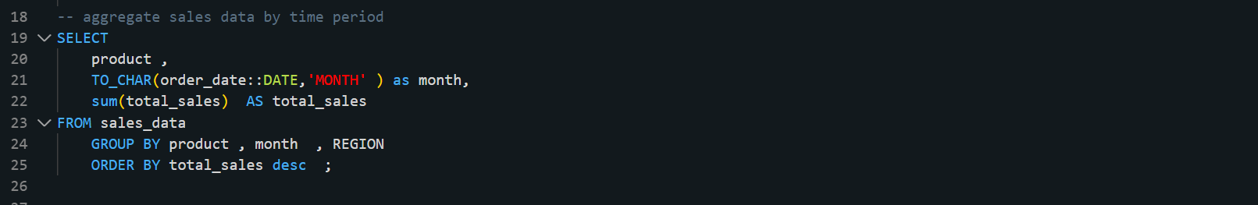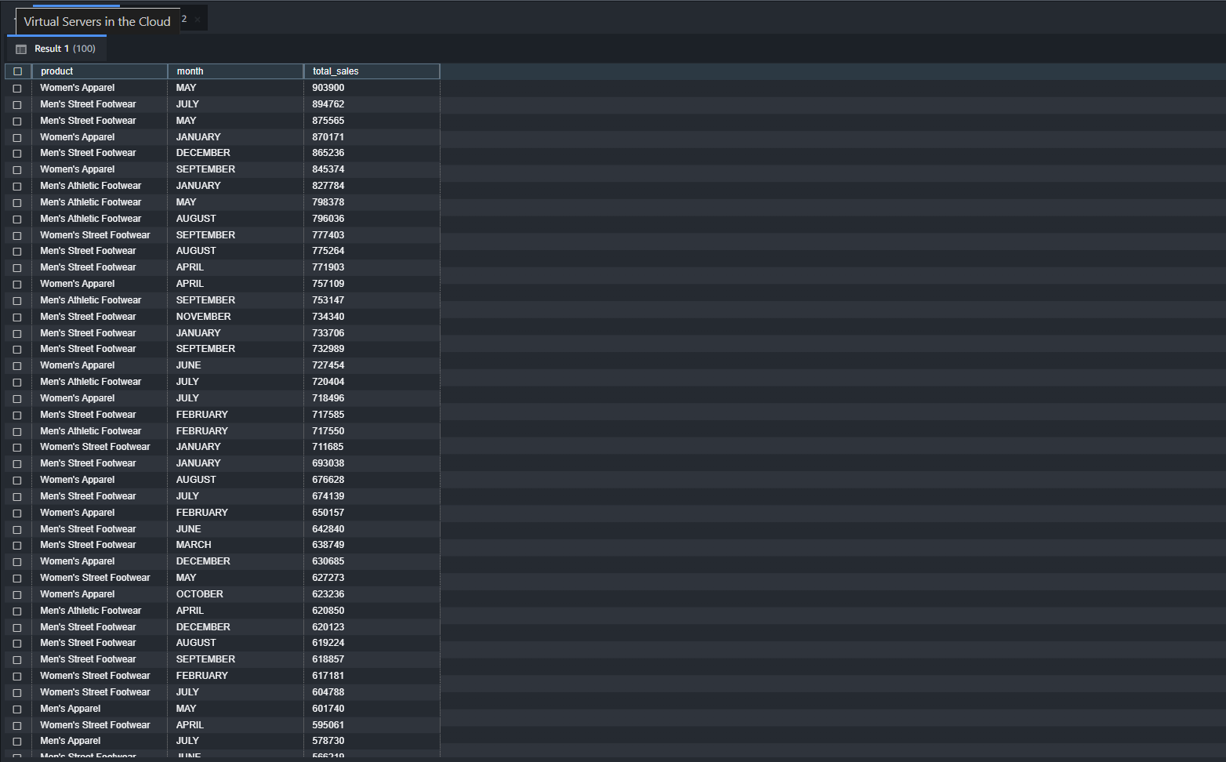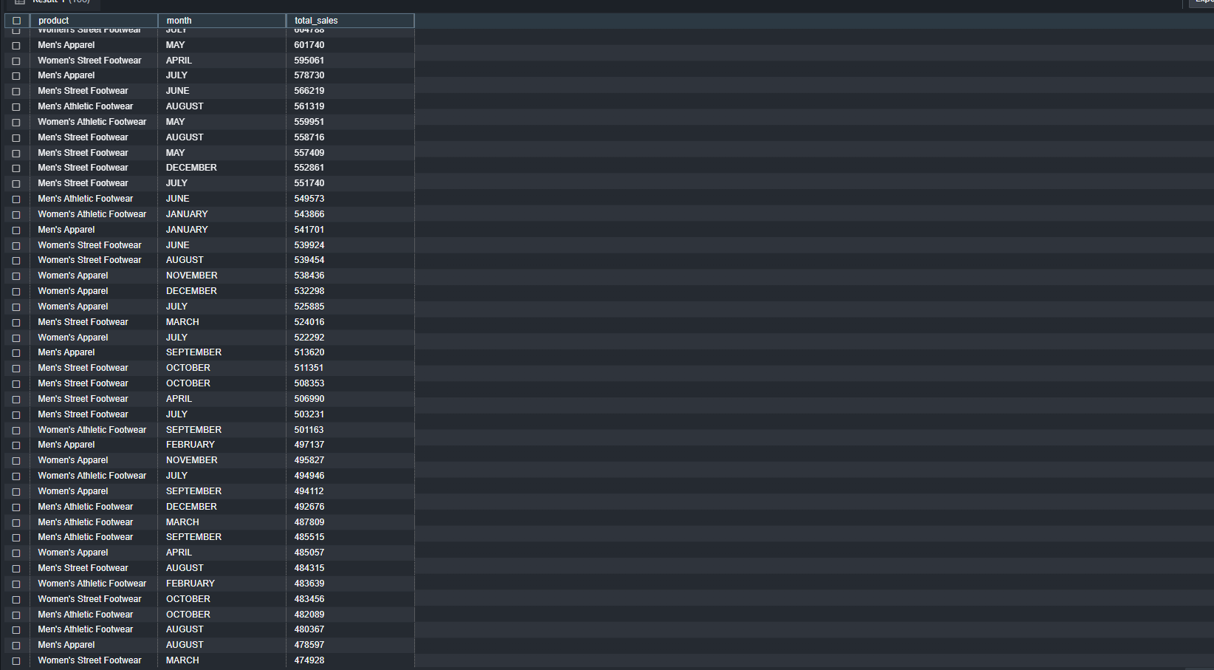

Identify top-selling products by calculating total sales or units sold.

By total sales

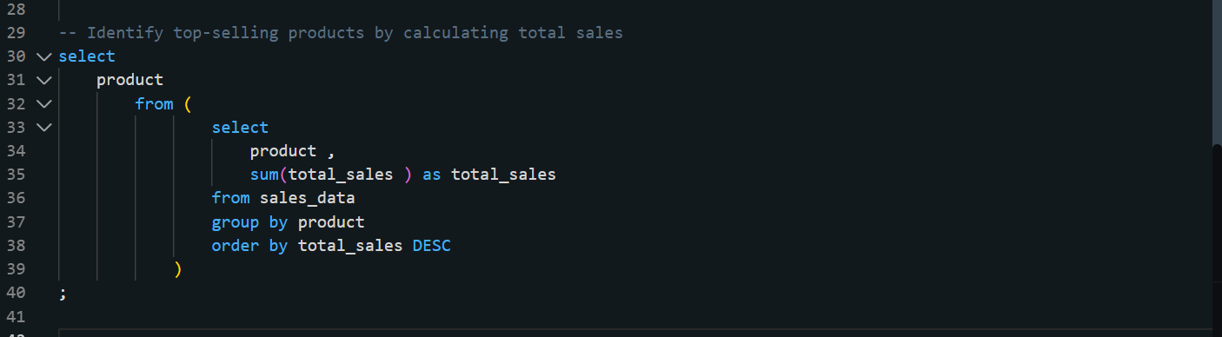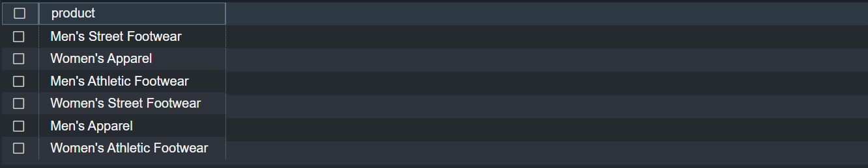

By units sold

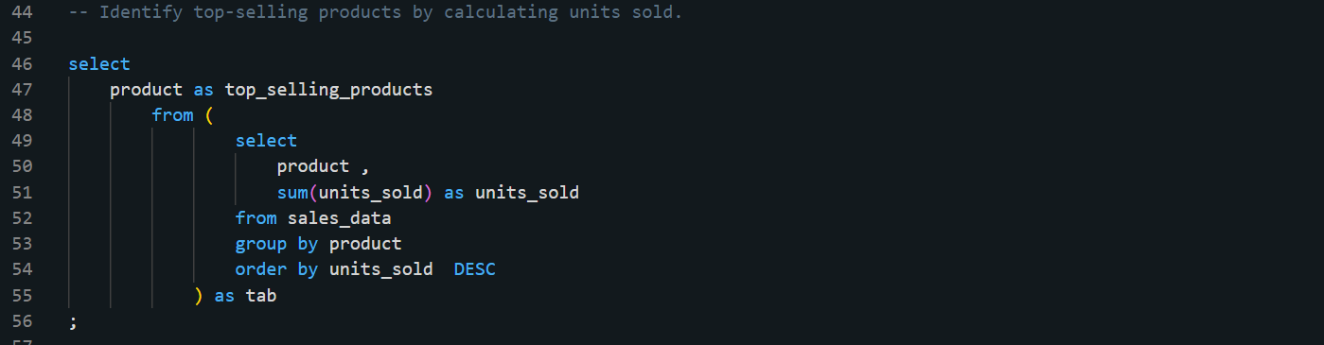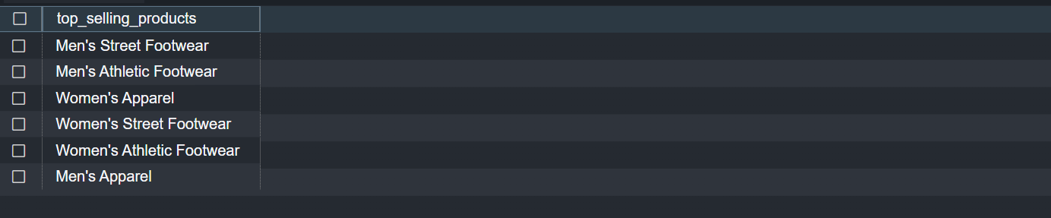

Determine highest revenue-generating regions by analyzing sales revenue per region.

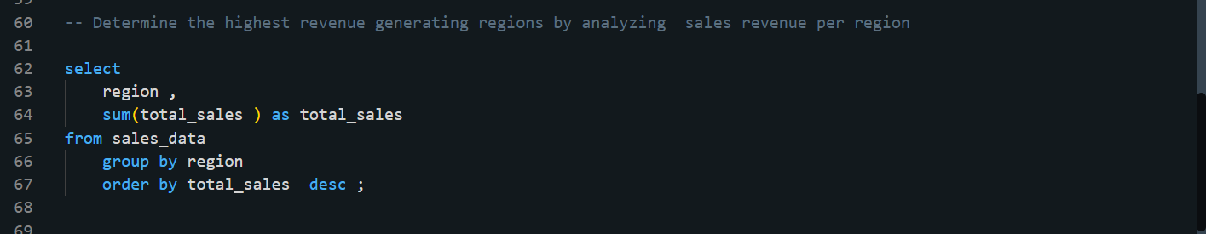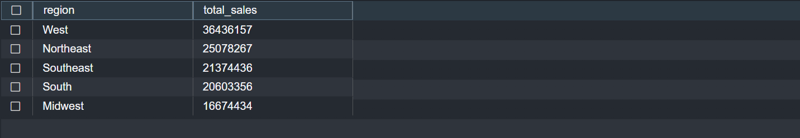

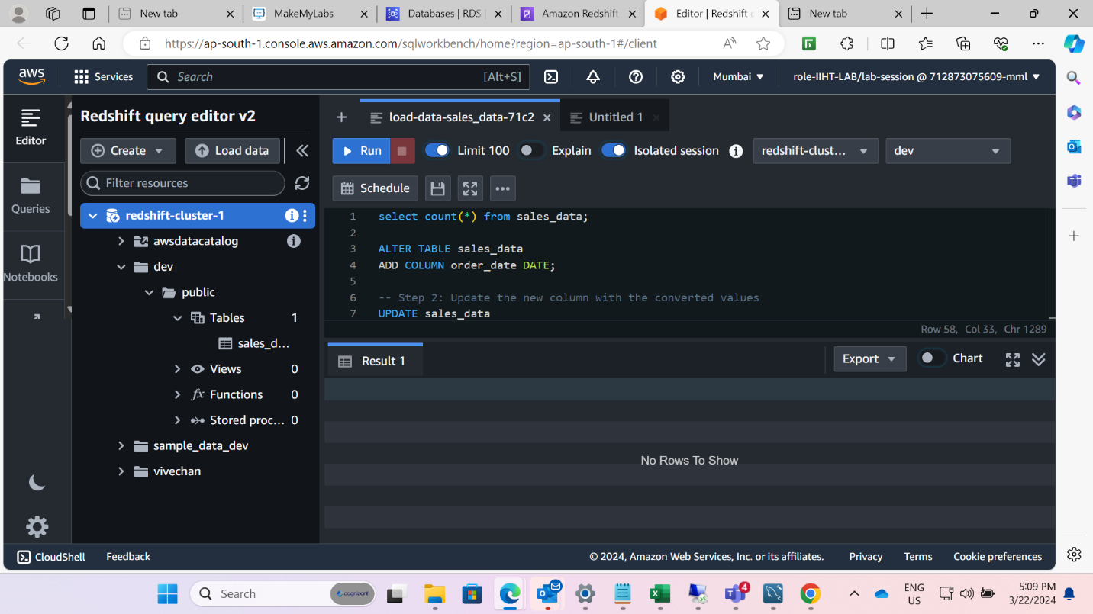



**Visualization**

For dashboarding we will be using AWS QuickSight Service

We first start importing data to QuickSight from Redshift Database

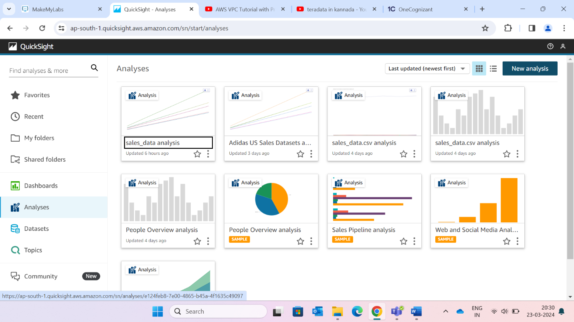

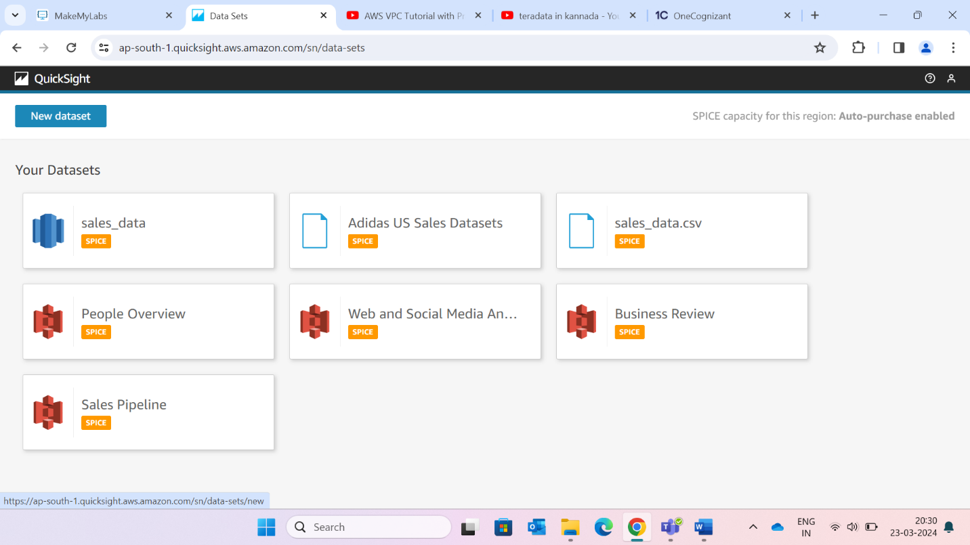

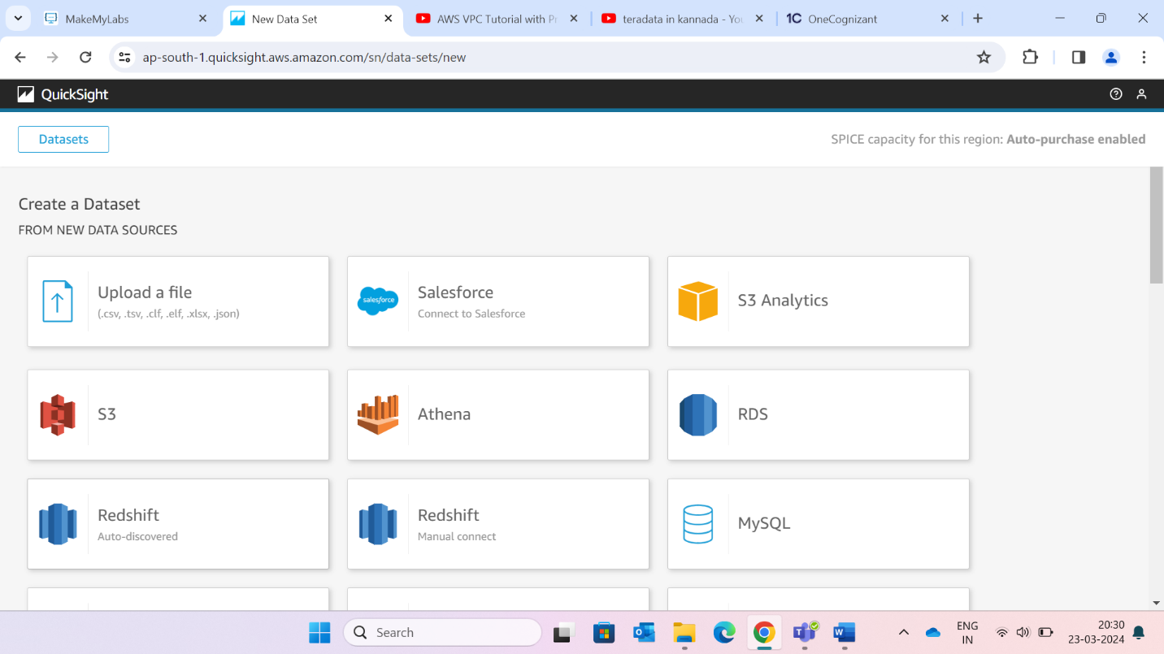

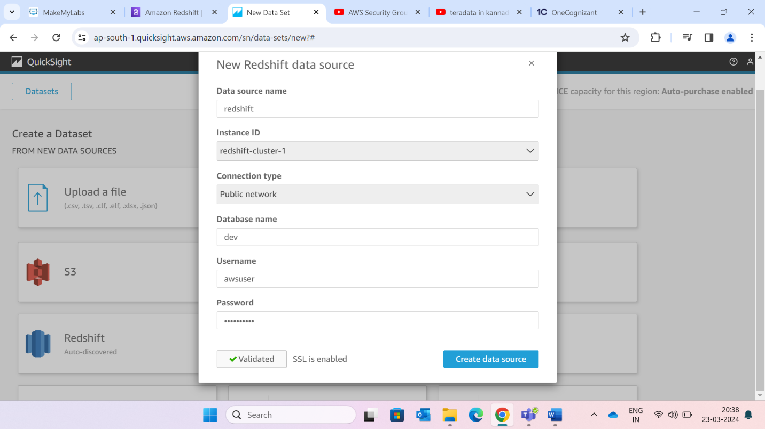

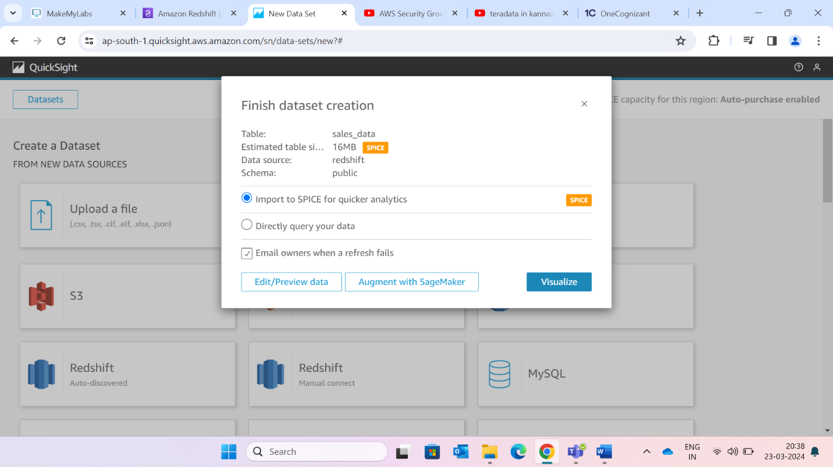

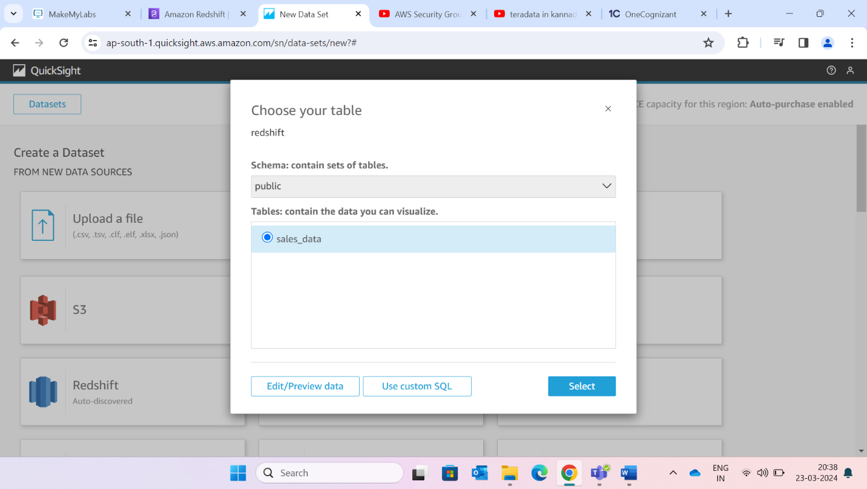

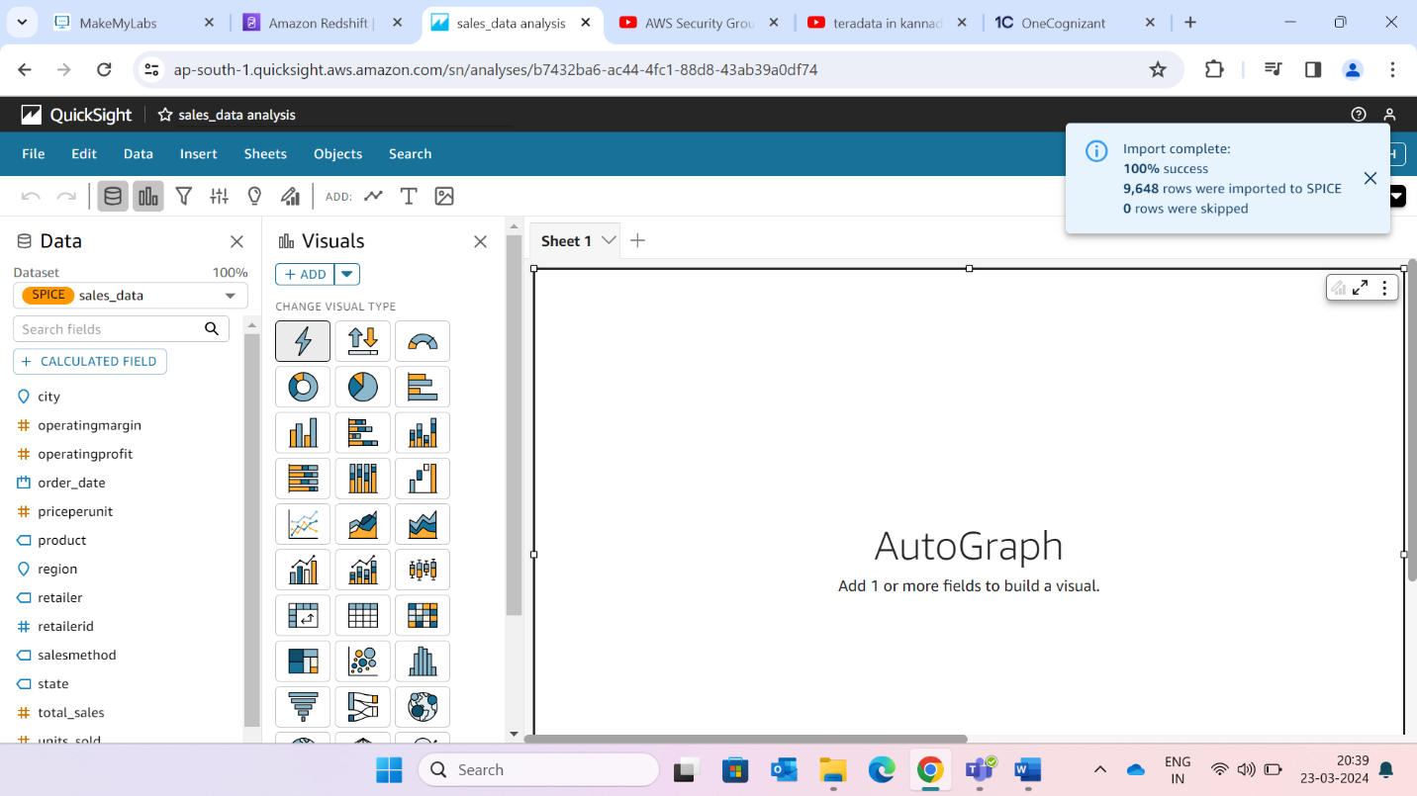

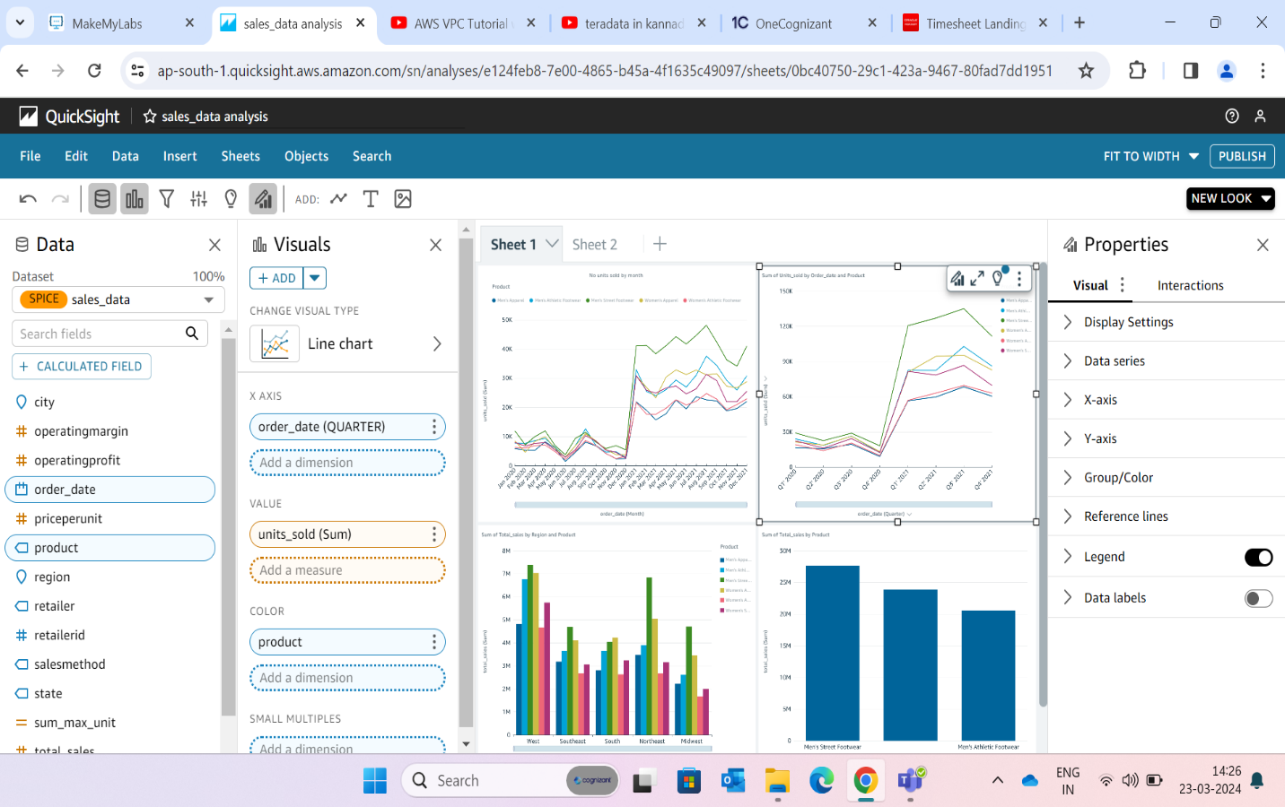

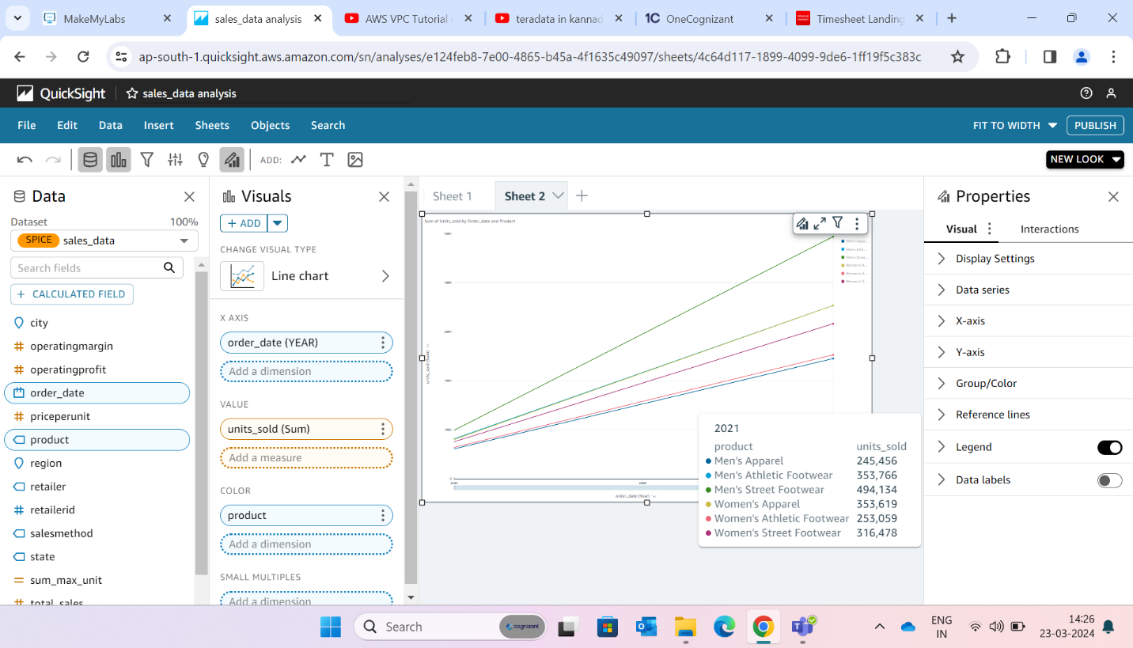

**Plotting no of units sold for each day**

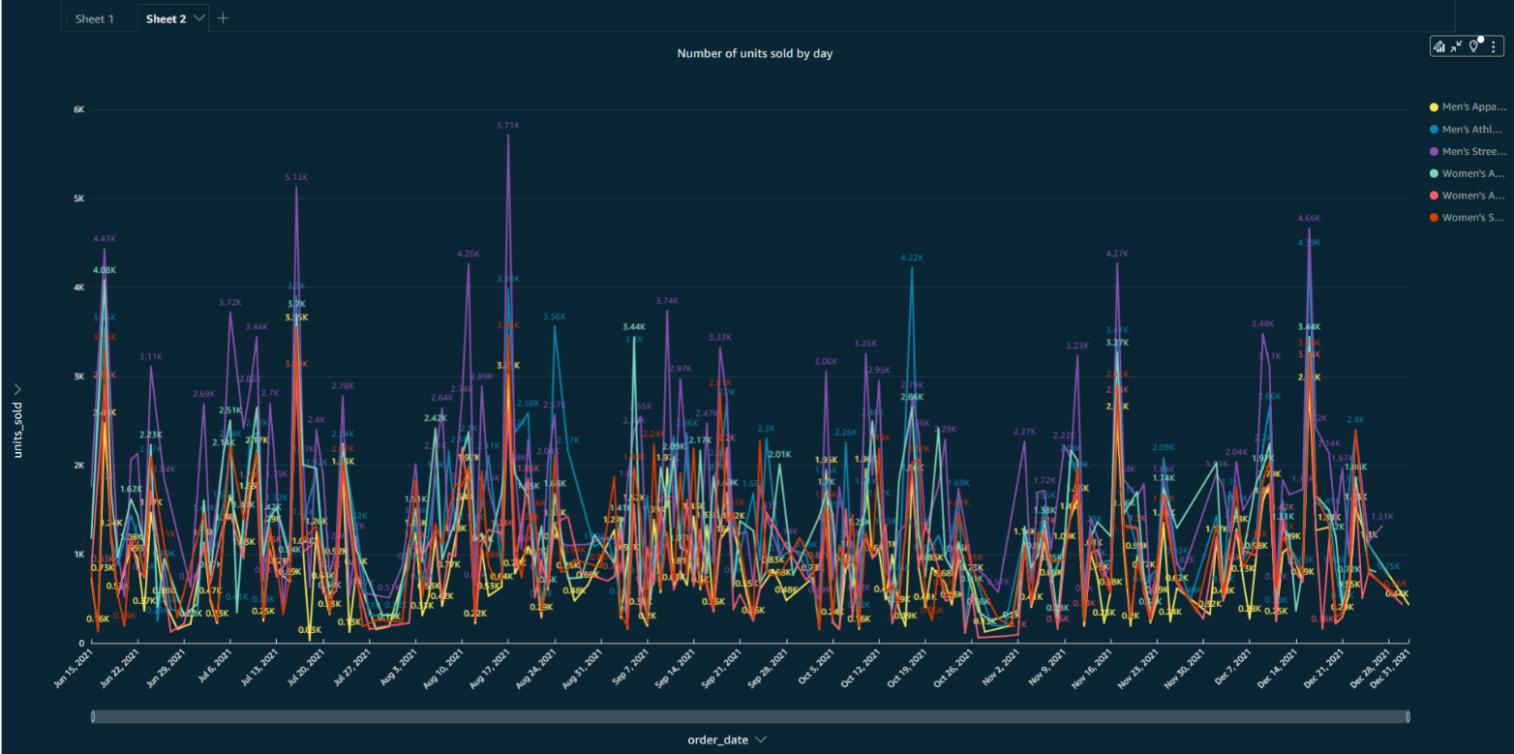

**Plotting no of units sold for each month**

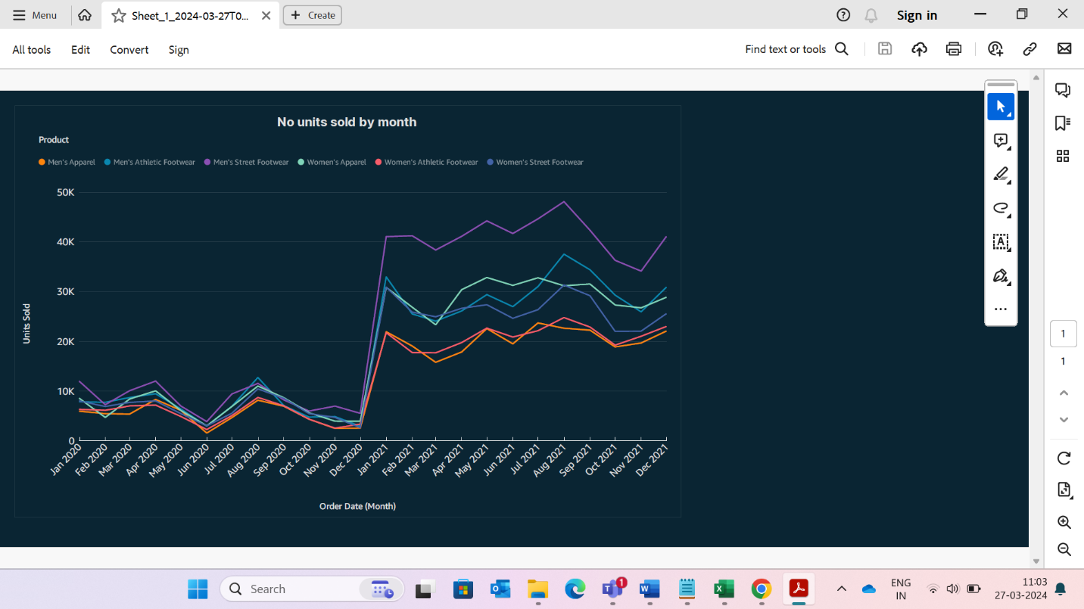

**Quarterly wise units sold**

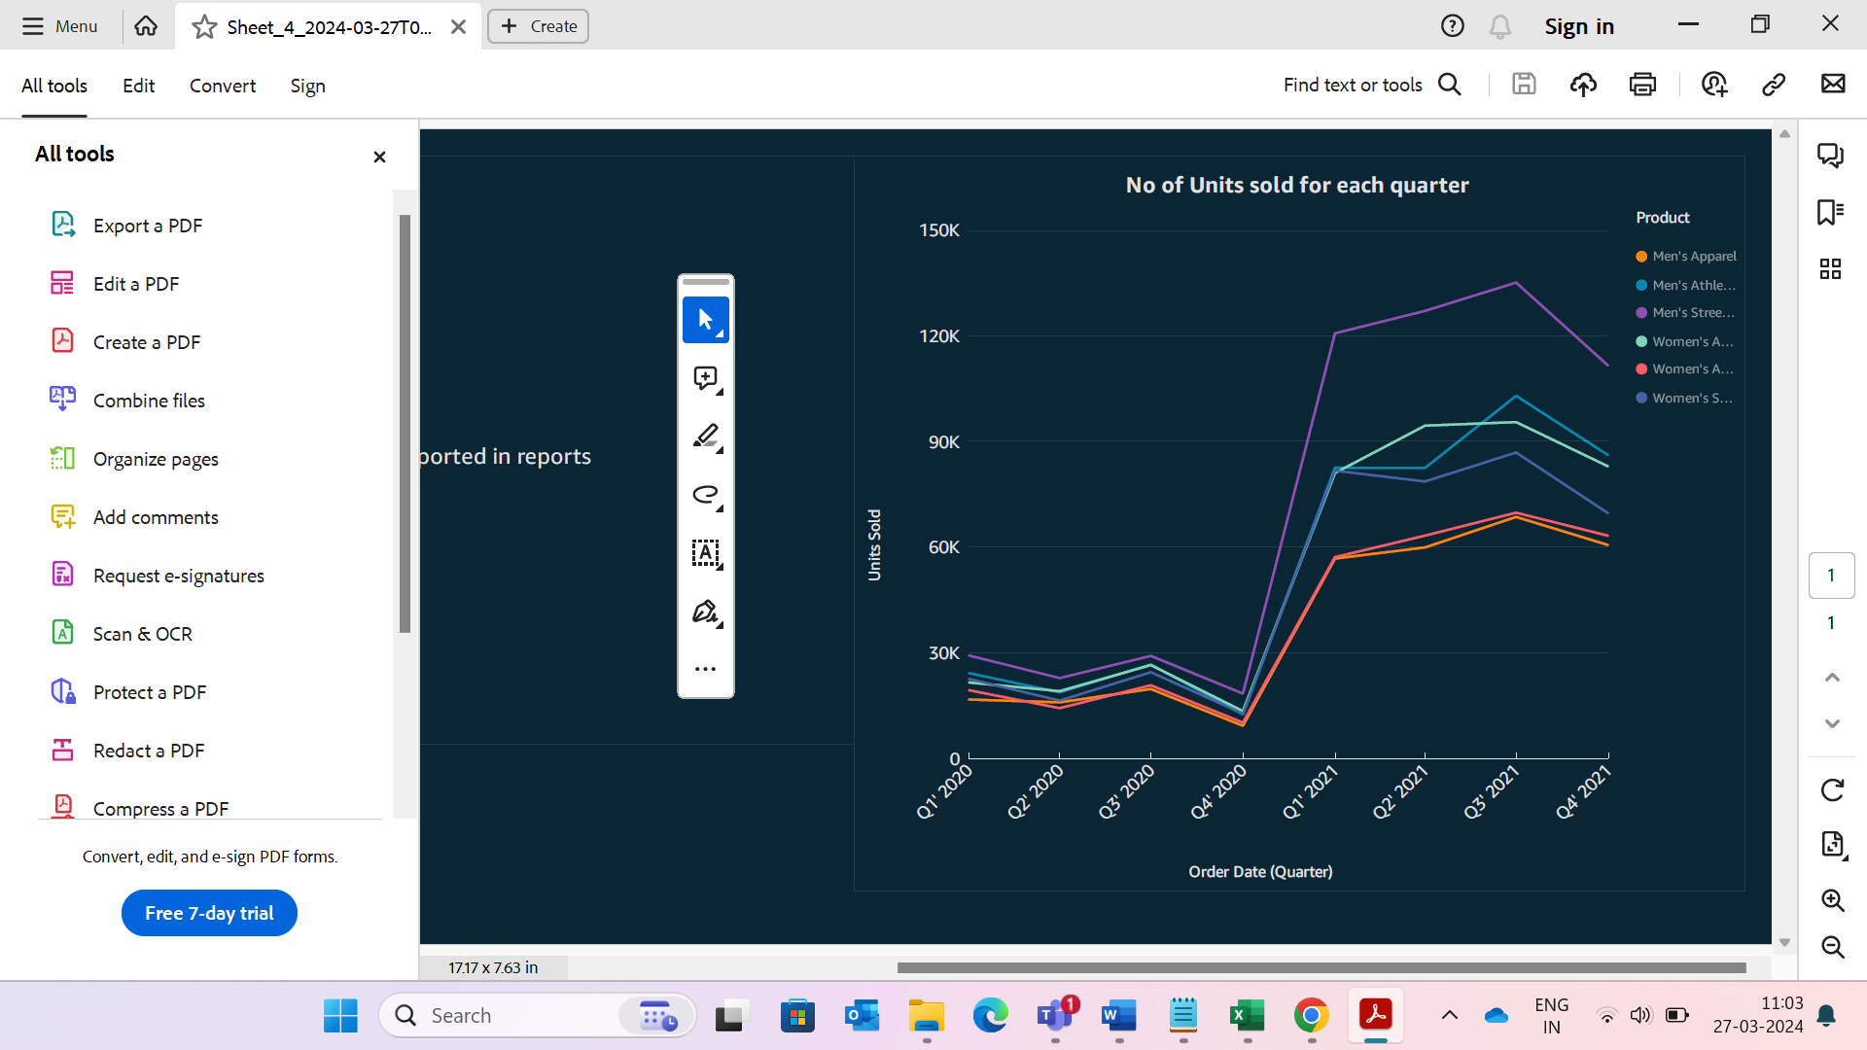

**Year wise units sold**

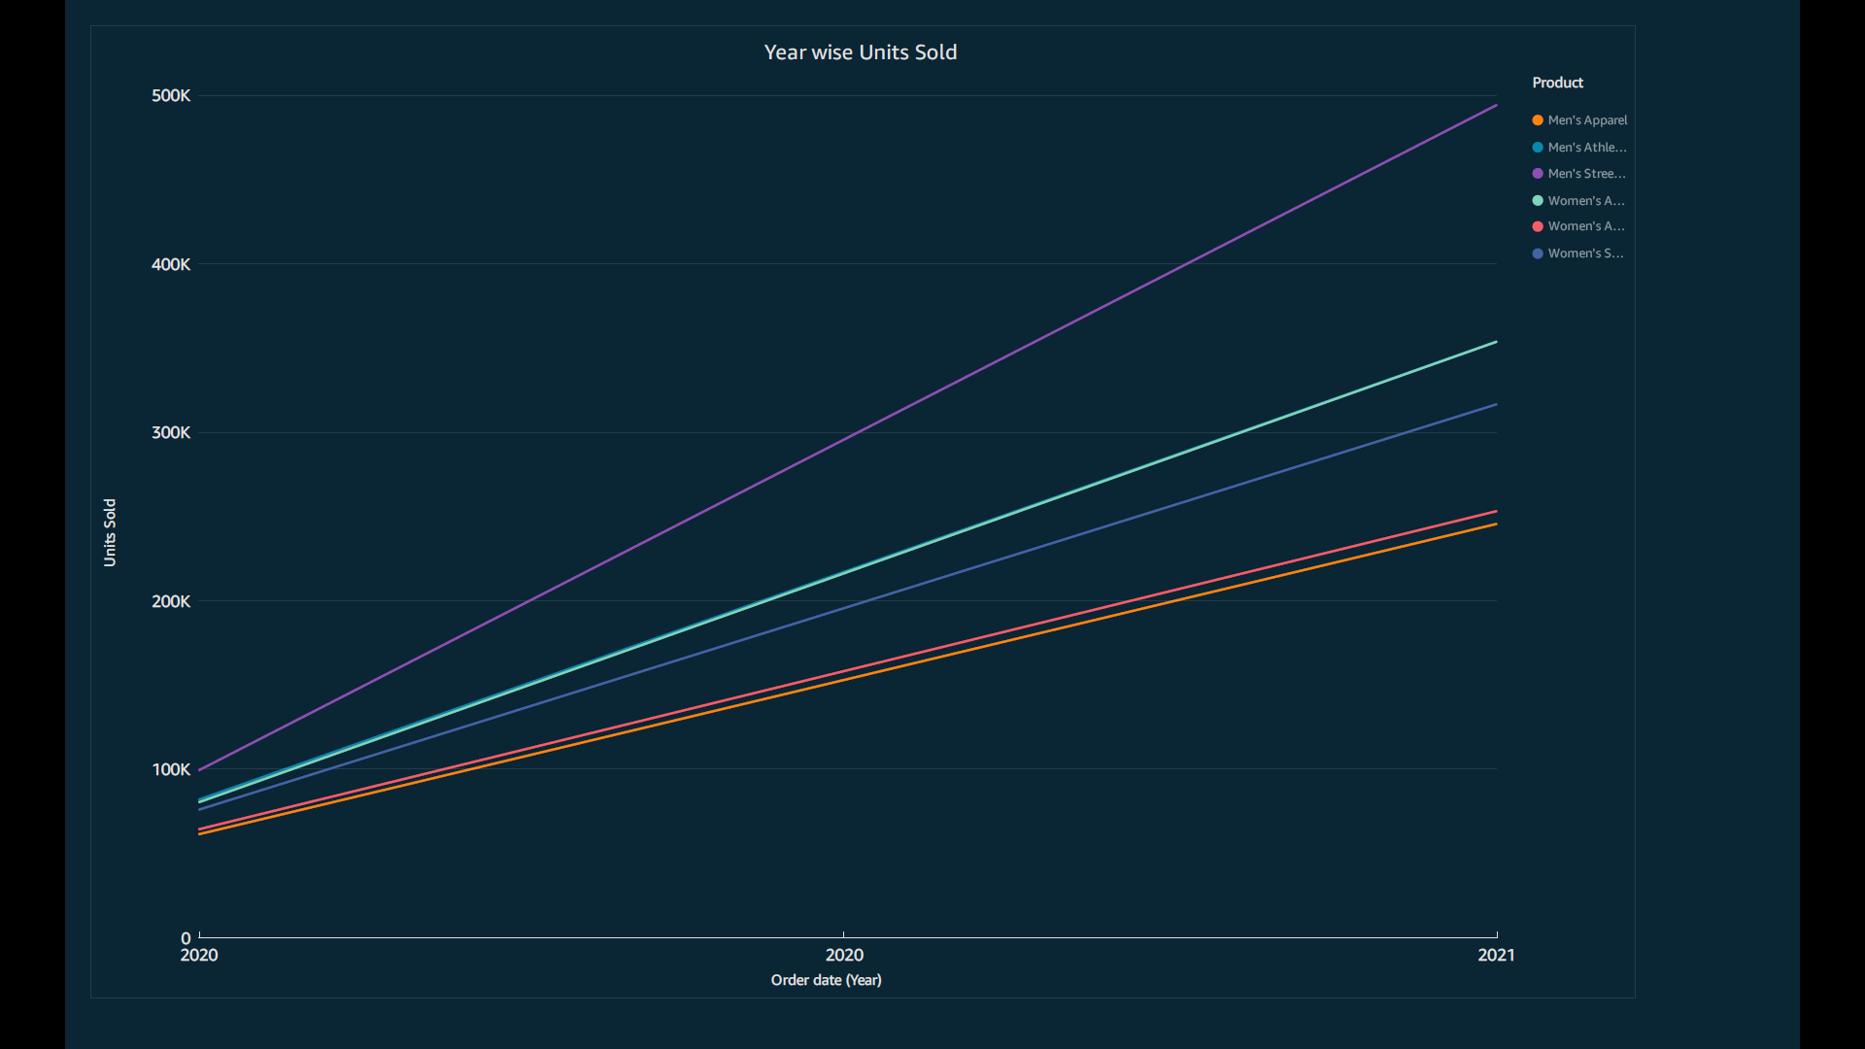

**Top 3 products by sales**

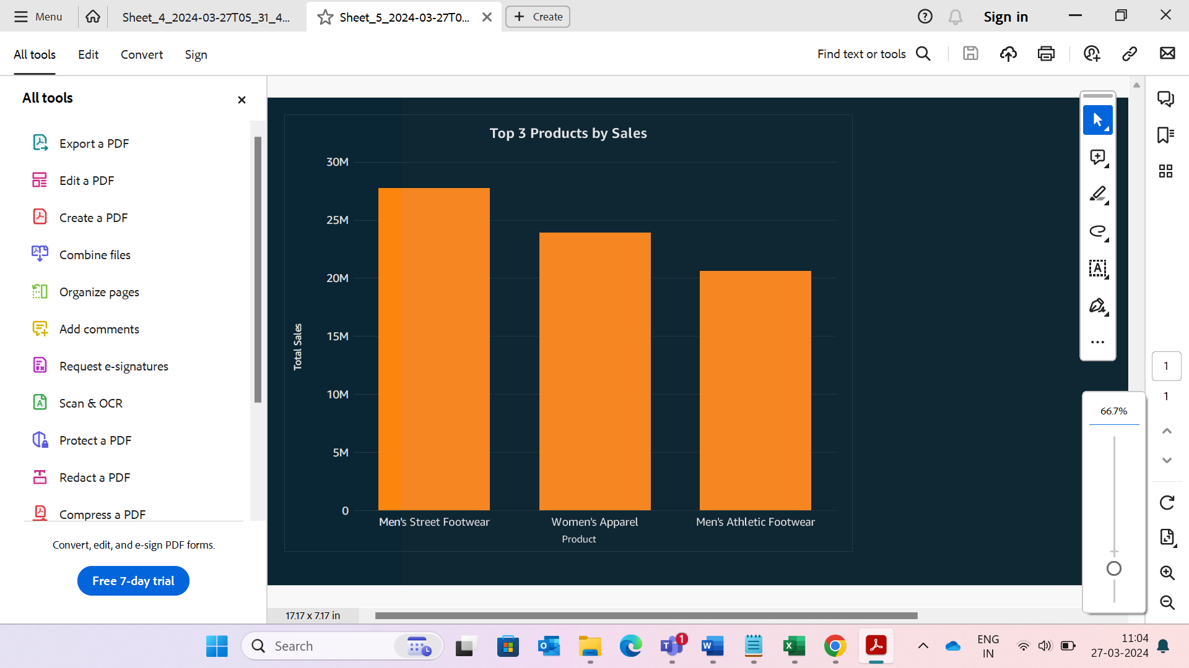

**Region wise product sales**

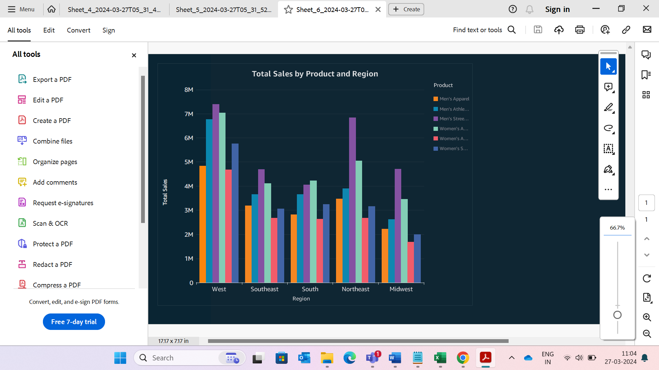

**Conclusion**

1. Data Warehousing with Amazon Redshift: By leveraging Amazon Redshift, we successfully centralized and managed the sales data. Redshift’s scalability and performance allowed us to handle large volumes of information efficiently. We transformed raw data into a structured format, enabling complex queries and aggregations. The data warehouse served as the backbone for our analysis, providing a solid foundation for further insights.
2. Visual Insights with Amazon Quick Sight: Amazon Quick Sight played a pivotal role in turning data into actionable insights. We created interactive dashboards and visualizations that allowed stakeholders to explore sales trends, product performance, and customer behavior. Quick Sight’s user-friendly interface empowered business users to make informed decisions without relying on technical expertise. Whether tracking revenue, monitoring inventory, or identifying growth opportunities, Quick Sight provided a responsive platform for data exploration.

“Armed with Redshift and Quick Sight, the sales team can gain valuable insights. They can identify top-performing products, can analyze regional sales patterns, and optimize inventory management. By embracing AWS tools, they can elevate their sales analysis capabilities, driving smarter business decisions and enhancing overall performance”.